# No8

# Foundation

Foundation module allows the setup and parametisation of policies and dependencies required by other modules under ILMU.

## Maintenance

### Patron Details

Patron Details Maintenance stores and maintains the patron details.

**Steps**

1. Select **Foundation** module.
2. Click on **Maintenance** and then **Patron Details**.
3. The screen below will be displayed.

Figure 8.1: Patron Details dialog box

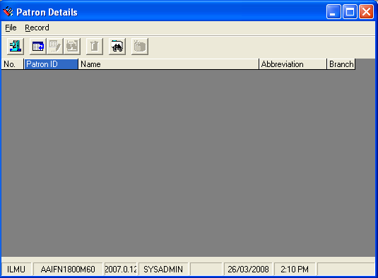

#### Add New Patron

**Steps**

1. In **Record** menu, choose **Add** or click on  icon.
2. **Add Patron Details** screen will appear as below.

Figure 8.2: Add Patron Details dialog box

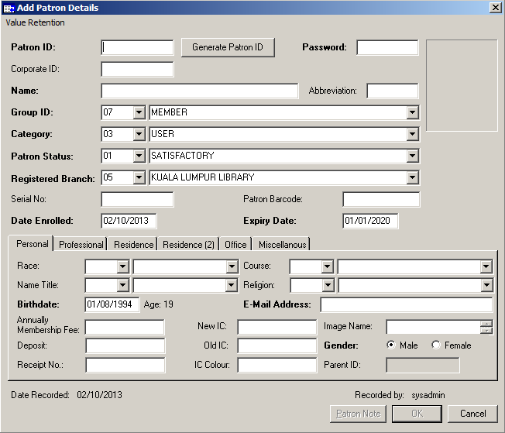

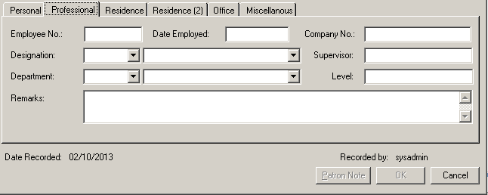

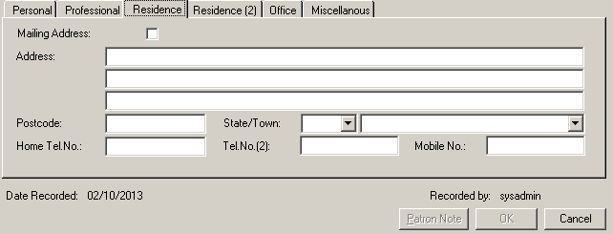

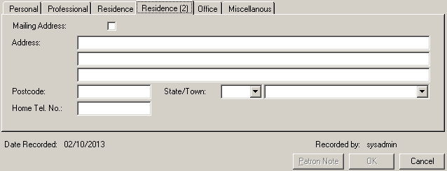

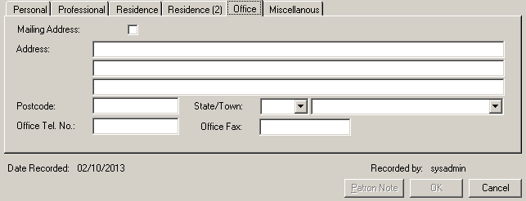

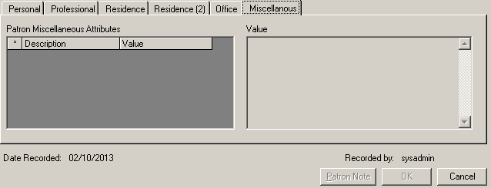

1. If you cannot recall the Patron ID, click the **Patron ID** button, it will auto generate new Patron ID for you.
2. Proceed to enter the relevant patron information. Notice the **OK** button is disabled. It will only be enabled when the mandatory fields (**bold**) have been entered.
3. Click on **OK** button to save the patron details. If you wish to about this process, just click **Cancel** and the information will not be saved.

#### Retrieve Patron Record

**Steps**

1. In **Record** menu, choose **Find** or click on  icon.
2. You will see **Search Criteria** screen will appear as below.

Figure 8.3: Search Criteria dialog box

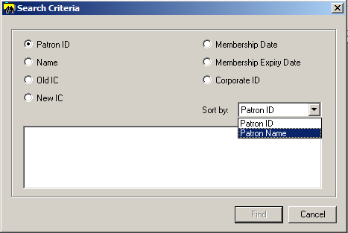

1. Choose a search criterion by clicking the selected radio button.
2. Choose **Patron ID** or **Patron Name** from Sort By list box.
3. Enter search term in the text area and click **Find** button. The search result will be displayed as below.

Figure 8.4: Search Result dialog box

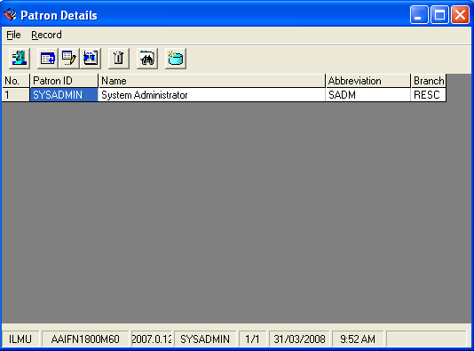

#### View Patron Record

**Steps**

1. Before viewing a particular patron record, first retrieve the record. Highlight a row to view its details.
2. After that in **Record** menu, choose **View** or click on  icon.
3. View Patron Details dialog box will be displayed.

Figure 8.5: View Patron Details dialog box

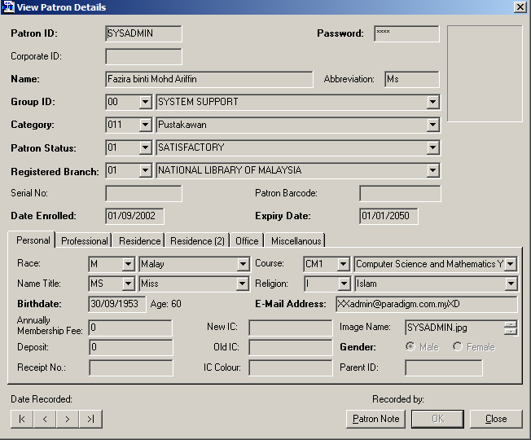

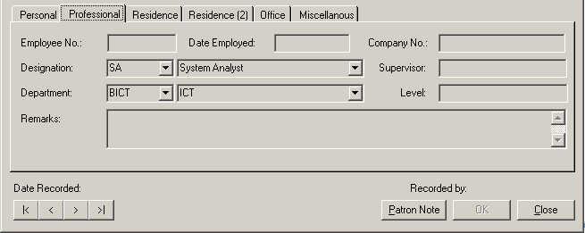

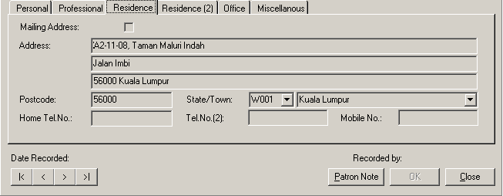

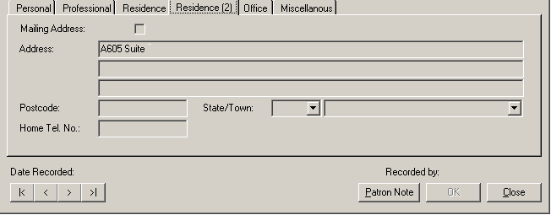

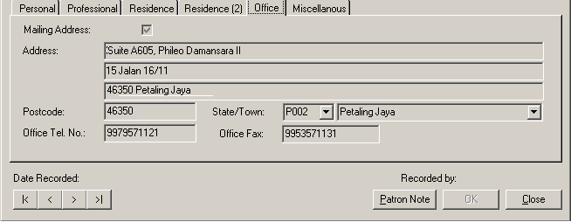

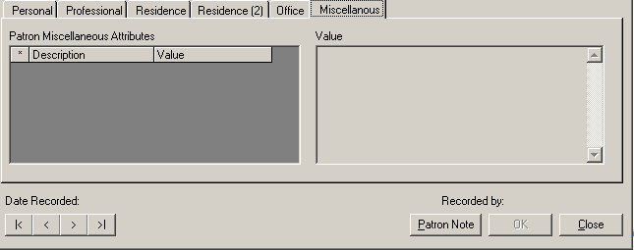

1. Click the **Close** button to close the View Patron Detailsdialog box.

#### Edit Patron Record

**Steps**

1. Retrieve patron record before editing the particular record. Highlight a row to edit its details.
2. After that in **Record** menu, choose **Edit** or click on  icon.
3. Edit Patron Details dialog box will be displayed.

Figure 8.6: Edit Patron Details dialog box

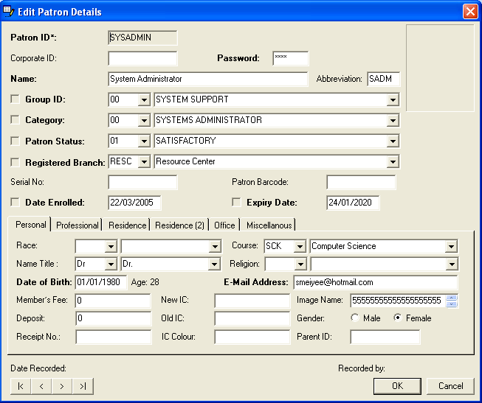

1. Make necessary amendments. Click **OK** button.

#### Delete Patron Record

**Steps**

1. Retrieve patron details. Highlight a row to delete its details.
2. After that in **Record** menu, choose **Delete** or click on  icon.
3. **Delete Patron Details** dialog box will be display as below.

Figure 8.7: Delete Patron Details dialog box

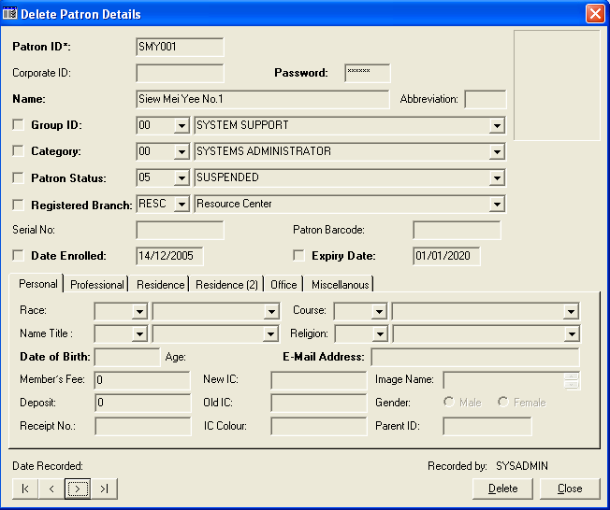

1. Click on **Delete** button.

Figure 8.8: Message prompt before deleting patron record

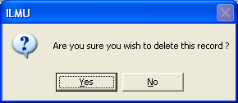

1. Click on **Yes** button to continue with deletion.
2. Click on **No** buttonto cancelthe deletion process.
3. If you successfully delete the patron delete, a message prompts as below.

Figure 8.9: Message prompt after deleting patron record

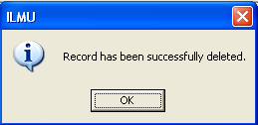

#### Refresh Patron Record

**Steps**

1. Retrieve patron details.
2. In the **Record** menu, choose **Refresh** or click on icon.
3. The Patron Details dialog box will be refreshed.

#### Closing Patron Eligibility

**Steps**

1. To close the Patron Details dialog box, click on **File** and choose **Close** or you can click the.

### Patron Eligibility

The **Patron Eligibility** function is to come up with sets of borrowing eligibility based on Patron Category.

**Steps**

1. Select **Foundation** module.
2. Click on **Maintenance** and then **Patron Eligibility**.
3. The screen will be displayed as shown in figure below.

Figure 8.10: Patron Eligibility dialog box

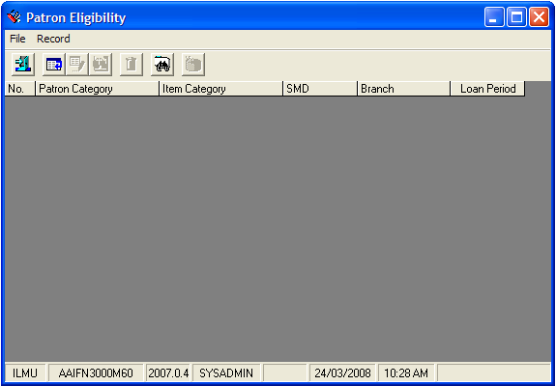

#### Add Patron Eligibilty

**Steps**

1. From figure above, click on **Record** in tab menu*,* and choose **Add**, or
2. You can click on add icon,  to add the new Patron Eligibility.
3. The**Patron Eligibility Wizard**dialog box will be appeared as shown in figure below.

Figure 8.11: Add Patron Eligibility dialog box

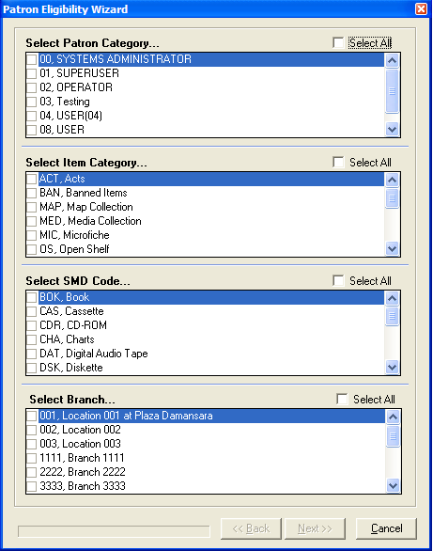

Select the Library Branch

Select the

Select the Item Category

Select the SMD Code

1. Click on a checkbox to select the Patron Category, Item Category, SMD Code and Branch.
2. Click the **Next** button. The following screen will be displayed as shown in figure below.

Figure 8.12: General information form

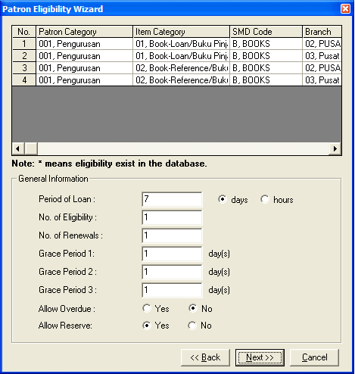

1. Fill in the necessary general information for the created patron eligibility.
2. Click the **Next** button. The screen will be displayed as shown in figure below.

Figure 8.13: Fines control form

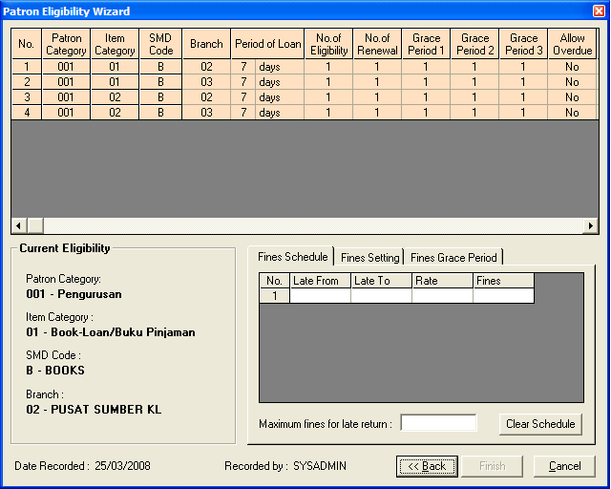

Fines Control tab

**Clear Schedule** button will reset the current settings

1. Fill in the necessary information in every Fines Control tab which consists of **Fines Schedule, Fines Settings** and **Fines Grace Period.**
2. Then, click the **Finish** button. The record(s) will be displayed in the following figure.

Figure 8.14: List of the record(s)

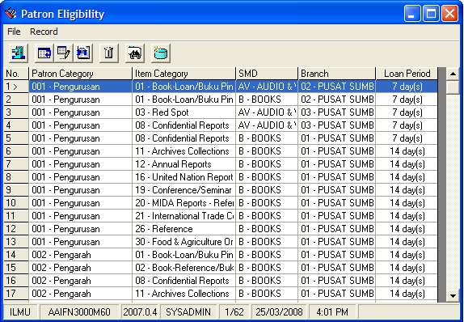

#### Find Existing Patron Eligibility

**Steps**

* + - 1. To find the existing Patron Eligibility record(s), click on **Record**tab and choose **Find** or
      2. Click on find icon,  in a screen to find the record(s)*.*  The **Search Criteria**dialog box will be appeared as shown in figure below.

Search term

Figure 8.15: Search criteria dialog box

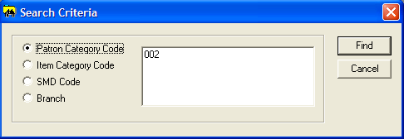

* + - 1. Choose search criteria by clicking a radio button. You can choose the criteria by:
* Patron Category Code
* Item Category Code
* SMD Code
* Branch
  + - 1. Enter search term and click on **Find** button. The screen will display the related eligibility sets as shown in figure below.

Figure 8.16: Display search result

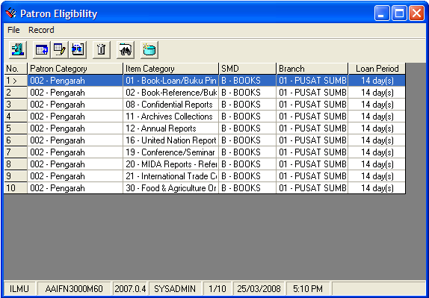

Related eligibility set

#### View Patron Eligibility

**Steps**

1. Click on **Record**tab and choose **View**, or
2. You can click the view icon*,*  to view the selected record. The **View Patron Eligibility** dialog box will be appeared as shown in figure below.

Figure 8.17: View Patron Eligibility dialog box

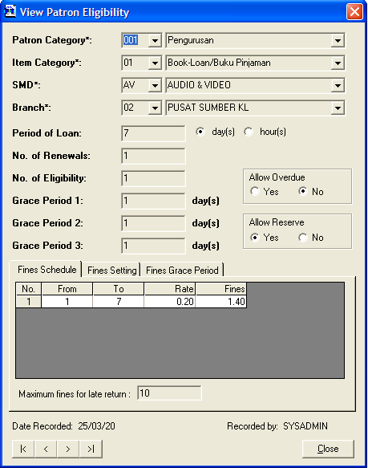

View the next or previous record(s).

1. You can view the other record(s) by clicking on Next and Previous button as shown in figure above.
2. Then, click the **Close** button to close the View Patron Eligibilitywindow.

#### Edit Patron Eligibility

**Steps**

1. Click on the selected row to edit the eligibility set.
2. Click on **Record**tab and choose **Edit**, or you can click the edit icon.

1. The **Edit Patron Eligibility** dialog box will be appeared as shown in figure below.

Figure 8.18: Edit Patron Eligibility dialog box

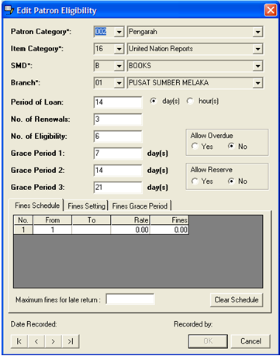

Edit the next or previous record.

1. Make necessary amendments to the eligibility set.
2. Then, click on **OK** button. The record will be updated in Patron Eligibility Maintenance dialog box.
3. You can edit the other record(s) by clicking on Next and Previous button as shown in figure above.
4. Otherwise, you can click on **Cancel** button to cancel the process.

#### Delete Patron Eligibility

**Steps**

1. From Patron Eligibility Maintenance dialog box, click on the selected row to delete the eligibility set. (Make sure the eligibility chosen is not being referred to for circulation transaction at the moment).
2. Click on **Record**tab and choose **Delete**, or you can click the edit icon*,* .
3. The screen will be displayed as shown in figure below.

Figure 8.19: Delete Patron Eligibility dialog box

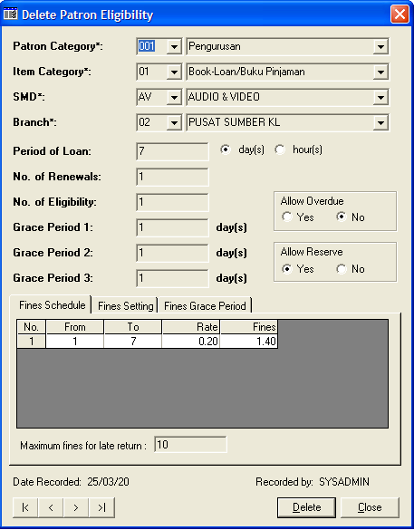

* + - 1. Click **Delete** button. A message box as below will be appeared.

Figure 8.20: Prompt message

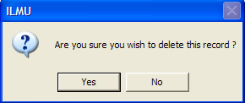

1. Click on **Yes** button. A message box will be appeared as shown in figure below.

Figure 8.21: Successful message

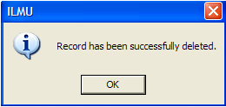

1. Click the **OK** button to complete the process.

#### Refresh Patron Eligibility

**Steps**

1. Click on **Record**tab and choose **Refresh**, or you can click the refresh icon*,* *.*
2. The entire Patron Eligibility dialog box will be refreshed.

#### Closing Patron Eligibility

**Steps**

1. To close the Patron Eligibility dialog box, click on File and choose Close or you can click the .

### Menu

Menu function will store all the details about every module.

**Steps**

1. Select **Foundation** module.
2. Click on **Maintenance** and then **Menu**.
3. You will see a message prompt before display **Menu** dialog box.

Figure 8.22: Message prompts before load records

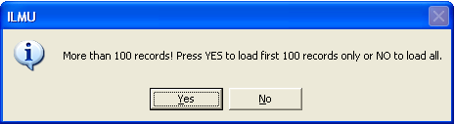

1. A message prompts as above, Click on **Yes** button to load first 100 records. Otherwise click on **No** button to load all records.

Figure 8.23: Load first 100 records

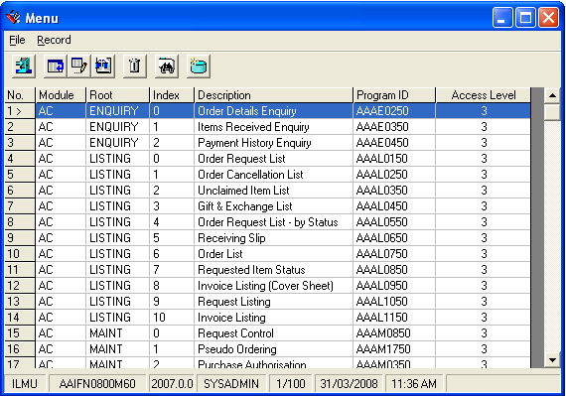

#### Add Menu Item

**Steps**

1. In **Record** menu, choose **Add** or click on  icon.
2. **Add Menu Item** screen will appear as below.

Figure 8.24: Add Menu Item dialog box

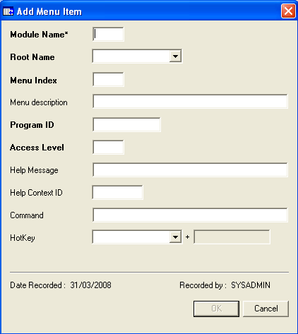

Note **Note:**

Access level populates function based on modules.

1. You will see the **OK** button will be enabled after you have entered all the mandatory fields.
2. Fill in the related details. Then click on **OK** button.

#### Retrieve Menu Item

**Steps**

1. In **Record** menu, choose **Find** or click on  icon.
2. **Search Criteria** screen will display as below.

Figure 8.25: Search Criteria dialog box for Menu

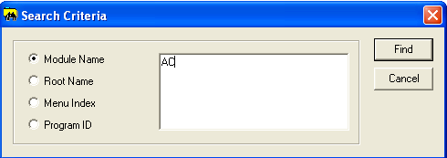

1. Choose search criteria by clicking the selected radio button.
2. Enter search term in the text area and click the **Find** button.
3. You will see all the menu items under Acquisition (AC) module will be displayed as below.

Figure 8.26: Menu Items under Acquisition (AC) module

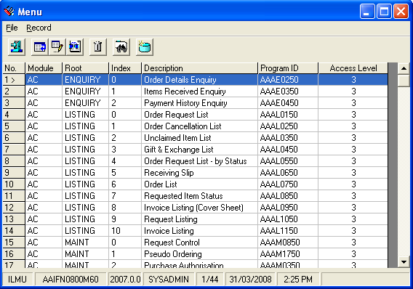

#### View Menu Item

**Steps**

1. In **Record** menu, choose **View** or click on  icon.
2. **View Menu Item** screen will display as below.

Figure 8.27: View Menu Item dialog box

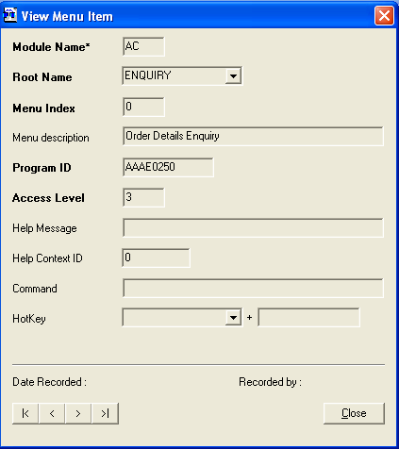

View the next or previous menu item.

1. Click the **Close** button to close the View Menu Itemdialog box.

#### Edit Menu Item

**Steps**

1. In **Record** menu, choose **Edit** or click on  icon.
2. **Edit Menu Item** screen will display as below.

Figure 8.28: Edit Menu Item dialog box

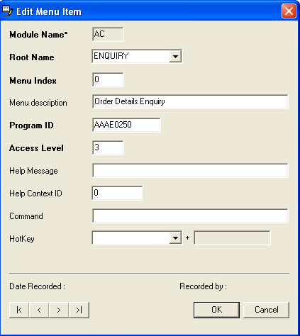

1. Make necessary amendments. Click on **OK** button.

#### Delete Menu Item

**Steps**

1. Menu Items that have been created will be displayed. Highlight a row to delete its details.
2. In the record menu, choose Delete or click on  icon.
3. **Delete Menu Item** screen will be displayed as below.

Figure 8.29: Delete Menu Item dialog box

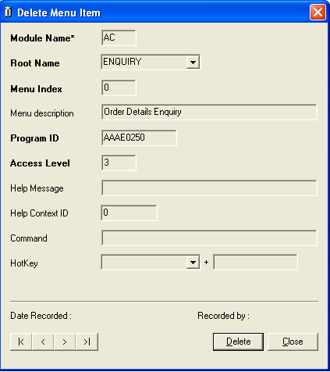

1. Click on the **Delete** button. A message prompts as below.

Figure 8.30: Message prompt before deleting menu item

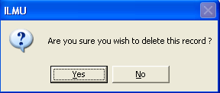

1. Click on **Yes** button to continue with deletion.
2. Click on **No** buttonto cancelthe deletion process.
3. If you successfully delete the patron delete, a message prompts as below.

Figure 8.31: Message prompt after deleting menu item

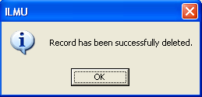

#### Refresh Menu Item

**Steps**

1. In the **Record** menu, choose **Refresh** or click on icon.
2. The Menu dialog box will be refreshed.

#### Closing Menu Item

**Steps**

1. To close the Menu dialog box, click on **File** and choose **Close** or you can click the.

### Race Code

The **Race Code** maintenance stores the race details. This function will be used as part of maintenance in Patron Details.

**Steps**

1. Select **Foundation** module.
2. Click on **Maintenance** and then **Race Code**.
3. The screen will be displayed as shown in figure below.

Figure 8.32: Race Code Maintenance dialog box

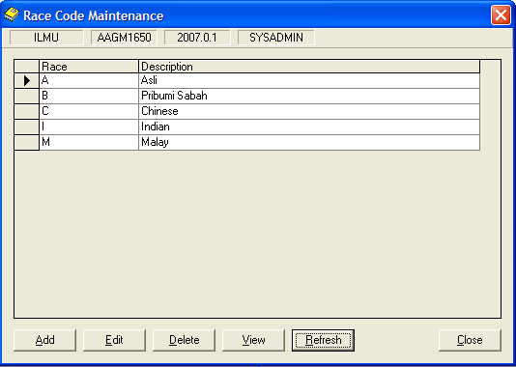

#### Add Race Code

**Steps**

1. From figure above, click on **Add** button. The following screen will be displayed.

Figure 8.33: Add Race Code dialog box

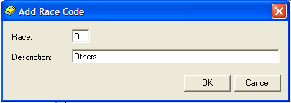

1. Enter the race code in text box and the description as shown in figure above.
2. Click on **OK** button. The latest race code created will be displayed in Race Code Maintenance dialog box as shown in figure below.
3. Otherwise, you can click on **Cancel** button to cancel the process.

Figure 8.34: Display the created race code

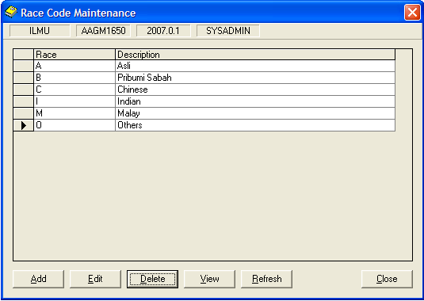

#### View Race Code

**Steps**

1. Race Codes that have been created will be displayed. Highlight the row to view its details.
2. Click the **View** button. **View Race Code** dialog box will be displayed as shown in figure below.

Figure 8.35: View race code dialog box

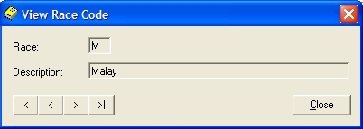

1. Click on **Close** button to close the dialog box

#### Edit Race Code

**Steps**

1. From figure above, highlight the row to edit Race Code details.
2. Click on **Edit** button. The **Edit Race Code** dialog box will be appeared as shown in figure below.

Figure 8.36: Edit Race Code dialog box

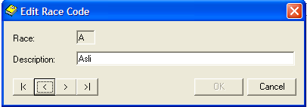

1. Make necessary amendments.
2. Then, click the **OK** button. The record will be updated in Race Code Maintenance dialog box.
3. You can edit the other record(s) by clicking on Next and Previous button as shown in figure above.
4. Otherwise, you can click on **Cancel** button to cancel the process.

#### Delete Race Code

**Steps**

1. From Race Code Maintenance dialog box, highlight the row to delete Race Code details.
2. Click on **Delete** button. The message dialog box will be appeared as shown in figure below.

Figure 8.37: Prompt Message dialog box

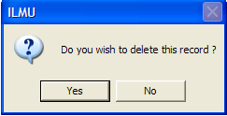

1. Click on **Yes** button. The highlighted record will be deleted. The successful message will be displayed as shown in figure below.
2. Otherwise, you can click on **No** button to cancel the process.

Figure 8.38: Successful message

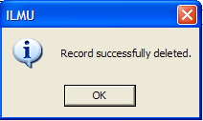

1. Click on **OK** button to complete the process.

#### Refresh Race Code

**Steps**

1. Click the **Refresh** button.
2. The **Race Code Maintenance**dialog box will be refreshed.
3. Click on **Close** button to close the dialog box.

### Course Code

The **Course Code** maintenance stores the Course details.

**Steps**

1. Select **Foundation** module.
2. Click on **Maintenance** and then **Course Code**.
3. The screen will be displayed as shown in figure below.

Figure 8.39: Course dialog box

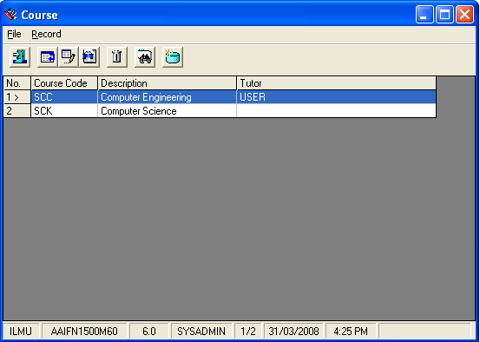

#### Add Course Code

**Steps**

1. From figure above, click on **Record** menu and choose **Add**. The following screen will be displayed.

Figure 8.40: Add Course dialog box

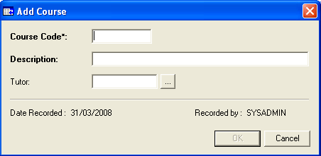

1. Fill the related details. The **OK** button will be enabled.
2. Click on **OK** button. The latest course code will be created in Course dialog box.

#### Retrieve Course Code

**Steps**

1. In **Record** menu, choose **Find** or click on  icon.
2. **Search Criteria** screen will display as below.

Figure 8.41: Search Criteria dialog box

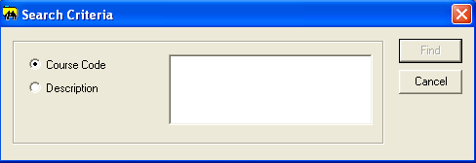

1. Click on the selected option button. Enter the search term.
2. Click on **Find** button.

#### View Course Code

**Steps**

1. Course Codes that have been created will be displayed. Highlight a row to view its details.
2. From **Record** Menu, choose **View** or click on  icon. View Course dialog box will be displayed.

Figure 8.42: View Course dialog box

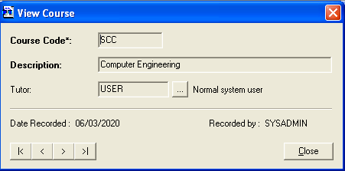

1. Click the **Close** button to close the View Course dialog box.

#### Edit Course Code

**Steps**

1. Course Codes that have been created will be displayed. Highlight a row to view its details.
2. From **Record** Menu, choose **Edit** or click on  icon. Edit Course dialog box will be displayed.

Figure 8.43: Edit Course dialog box

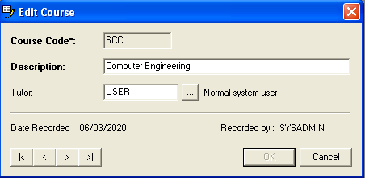

#### Delete Course Code

**Steps**

1. Course Code that has been created will be displayed. Highlight a row to delete its details.
2. In the record course code, choose **Delete** or click on  icon.
3. **Delete Course** screen will be displayed as below.

Figure 8.44: Delete Course dialog box

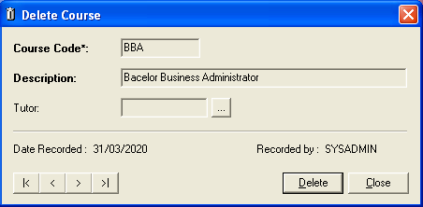

1. Click on the **Delete** button. A message prompts as below.

Figure 8.45: Message prompt before deleting course code

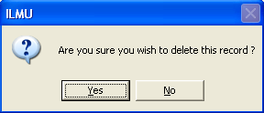

1. Click on **Yes** button to continue with deletion.
2. Click on **No** buttonto cancelthe deletion process.
3. If you successfully delete the patron delete, a message prompts as below.

Figure 8.46: Message prompt after deleting course code



#### Refresh Course Code

**Steps**

1. In the **Record** menu, choose **Refresh** or click on icon.
2. The Menu dialog box will be refreshed.

#### Closing Course Code

**Steps**

1. To close the Menu dialog box, click on **File** and choose **Close** or you can click the.

### Department Code

The Department Code Maintenance stores the Department details. The Department Code will be used as part of maintenance in Patron Details.

**Steps**

1. Select **Foundation** module.
2. Click on **Maintenance** and then **Department Code**.
3. The screen will be displayed as shown in figure below.

Figure 8.47: Department Code dialog box

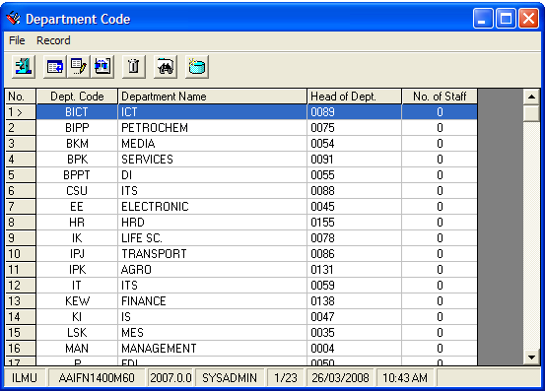

#### Add Department Code

**Steps**

1. From figure above, click on **Record** in tab menu*,* and choose **Add**, or
2. You can click on add icon,  to add the new Department Code.
3. The**Add Department Code**dialog box will be appeared as shown in figure below.

Figure 8.48: Add department dialog box

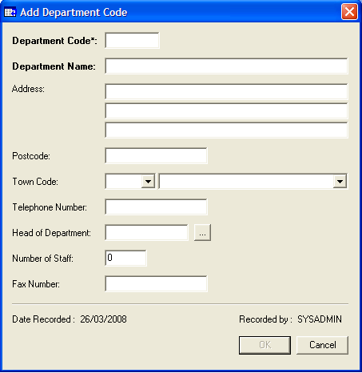

* + - 1. Fill in the related details. The **Department Code** and **Department Name** are mandatory fields.
      2. Click the **OK** button. The latest department code created will be displayed in **Department Code Maintenance** dialog box.
      3. Otherwise, you can click on **Cancel** button to cancel the process.

#### Find Existing Department Code

**Steps**

* + - 1. To find the existing Department Code record(s), click on **Record**tab and choose **Find** or
      2. Click on find icon,  in a screen to find the record(s)*.*  The **Search Criteria**dialog box will be appeared as shown in figure below.

Search term

Figure 8.49: Search criteria dialog box

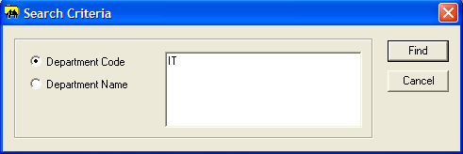

* + - 1. Choose search criteria by clicking a radio button. You can choose the criteria by:
* Department Code
* Department Name
  + - 1. Enter search term and click on **Find** button. The screen will display the related department code sets as shown in figure below.

Figure 8.50: Display search result

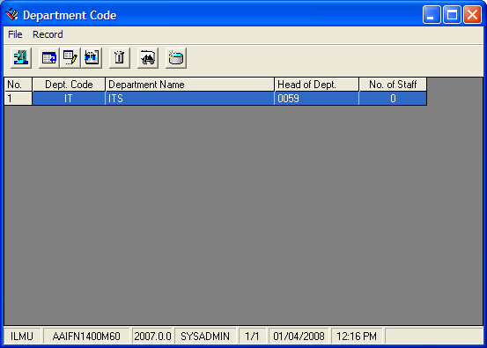

Related department code

#### View Department Code

**Steps**

1. Click on **Record**tab and choose **View**, or
2. You can click the view icon*,*  to view the selected record. The **View Department Code** dialog box will be appeared as shown in figure below.

Figure 8.51: View Department Code dialog box

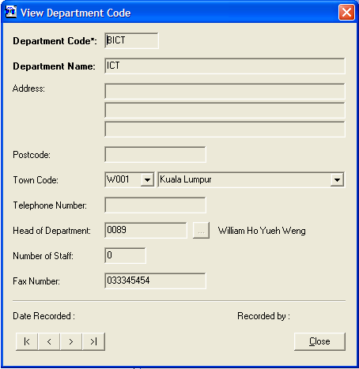

View the next or previous record(s).

1. You can view the other record(s) by clicking on Next and Previous button as shown in figure above.
2. Then, click the **Close** button to close the View Department Codewindow.

#### Edit Department Code

**Steps**

1. Department Code that has been created will be displayed. Highlight the row to edit its details.
2. Click on **Record**tab and choose **Edit**, or you can click the edit icon.
3. The **Edit Department Code** dialog box will be appeared as shown in figure below.

Figure 8.52: Edit Department Code dialog box

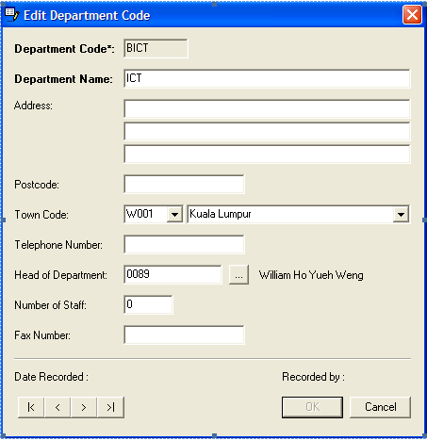

Edit the next or previous record(s).

1. Make necessary amendments.
2. Then, click the **OK** button. The record will be updated in **Department Code Maintenance** dialog box.

#### Delete Department Code

**Steps**

1. From Department Code Maintenance dialog box, highlight the row to delete Department Code details.
2. Click on **Record**tab and choose **Delete**, or you can click the delete icon*,* .
3. The screen will be displayed as shown in figure below.

Figure 8.53: Delete Department Code dialog box

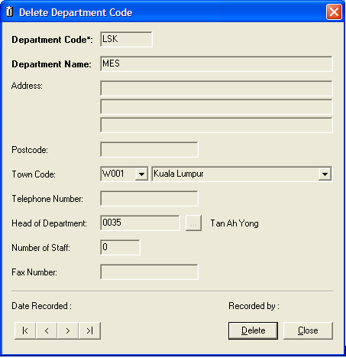

1. Click on **Delete** button. A message box will be prompted as shown in figure below.

Figure 8.54: Prompt message

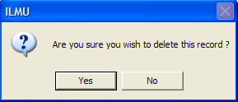

1. Click on **Yes** button. A successfully message will be appeared as shown in figure below. The record has been successfully deleted.

Figure 8.55: Successful message

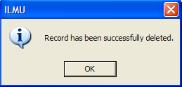

1. Click the **OK** button to complete the process.

#### Refresh Department Code

**Steps**

1. Click on **Record**tab and choose **Refresh**, or you can click the refresh icon*,* *.*
2. The entire Department Code Maintenance dialog box will be refreshed.
3. Click on **Close** button to close the dialog box.

#### Closing Department Code

**Steps**

1. To close the Department Code dialog box, click on **File** and choose **Close** or you can click the close icon .

### Time Class

Time Class Maintenance maintains the library opening and closing time.

**Steps**

1. Select **Foundation** module.
2. Click on **Maintenance** and then **Time Class**.
3. The Time Class Maintenance dialog box appears as below.

Figure 8.56: Time Class Maintenance dialog box

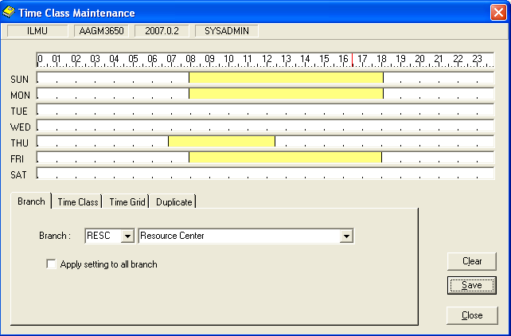

Branch tab

#### Set Branch

**Steps**

1. Click in the **Branch** tab.
2. Select branch from the list box.
3. You can click on the check box, if you want to apply setting to all branches.

#### Add Time Class

**Steps**

1. Click in the **Time Class** tab. A figure as below will be displayed.

Figure 8.57: Time Class dialog box

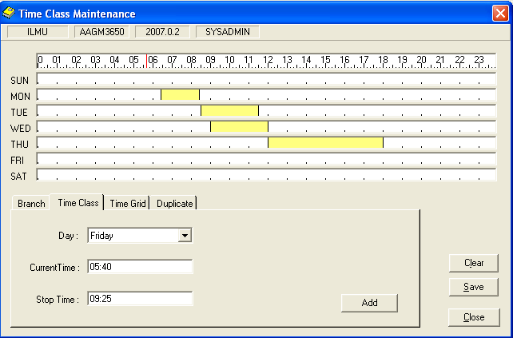

1. Select the Day, Current Time and Stop Time. You also can click on the grid to set the Current Time and Stop Time for the time class.
2. The time will be displayed on the Current Time text field and the Stop Time text field.
3. You can see **Add** button will be enabled, after you have added all the fields.
4. A yellow bar will be displayed on the time class grid.

#### Delete Time Class

**Steps**

1. Click on the yellow bar displayed on the time class grid. You can see **Delete** button in Time class dialog box.

Figure 8.58: Delete button displayed in Time Class dialog box

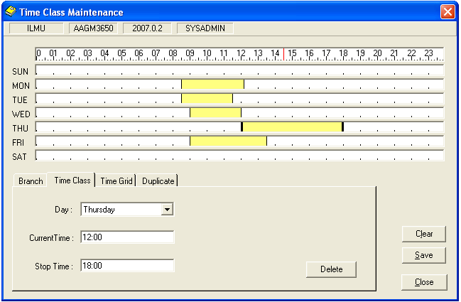

1. Click on the **Delete** button.
2. Click on the Clear button, to clear the time grid.
3. Click on **Save** button, to save the changes.

#### Setting Time Grid

**Steps**

1. Click on the **Time Grid** tab. The page below will be displayed.

Figure 8.59: Time Grid dialog box

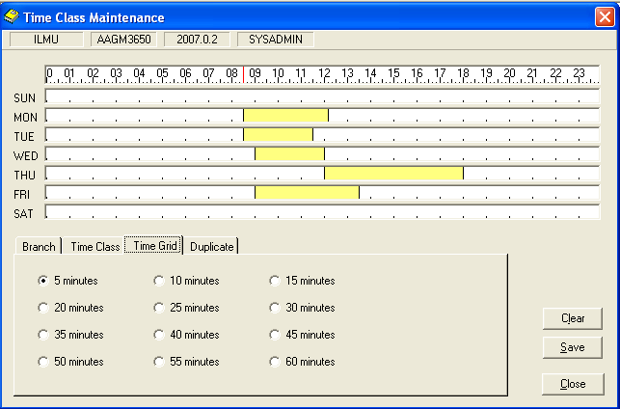

1. Select the scale of the Time Grid by selecting the time interval. (In minutes).
2. Click on the **Save** button after made a changes.

#### Duplicate Time Classes

**Steps**

1. Click on the **Duplicate** tab. The page below will be displayed.

Figure 8.60: Duplicate dialog box

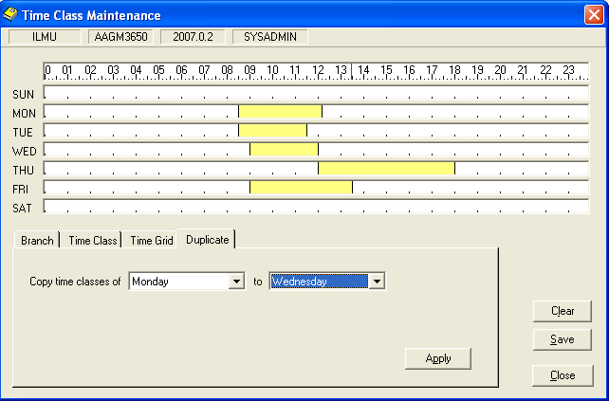

1. Click on the **Duplicate** tab. The page below will be displayed.
2. Select the day that you want to copy the time from and select the day where the time changes are to be applied.
3. Click the **Apply** button and save the changes by clicking the **Save** button.

### Library Calendar

Library Calendar function is to maintain library's operating days. This function is closely related to the circulation transactions dates performed by the library.

#### Highlighting Weekend

**Steps**

1. Select **Foundation** module.
2. Click on **Maintenance** and then **Library Calendar**.

Figure 8.61: Library Calendar dialog box

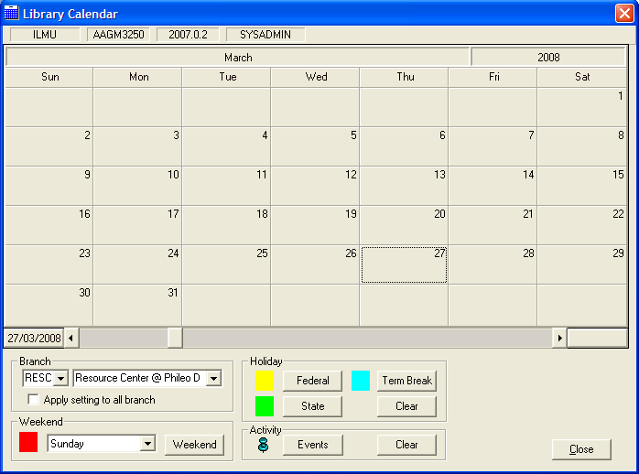

Holiday column

Activity column

Weekend column

1. In Weekend column, click the day(s) to be highlighted as Weekend.
2. Click **Weekend** button. System will highlight all boxes belonging to Weekend in red as shown in figure below.

Figure 8.62: Highlighted calendar for weekend days

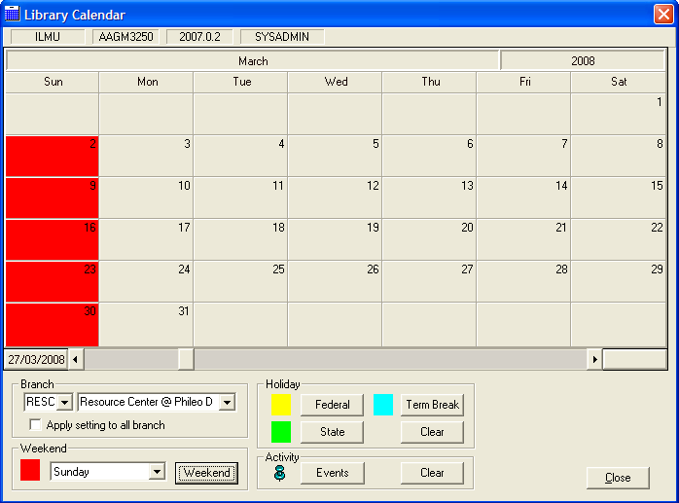

#### Highlighting Federal Day

**Steps**

1. Choose the date(s) to be highlighted as Federal Holiday.
2. In Holiday column, click the **Federal** button.
3. A message will be prompted as shown below. Enter appropriate description for Federal Holiday.

Figure 8.63: Prompt message

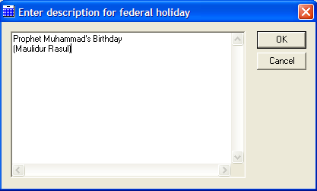

1. Click the **OK** button. System will mark the chosen date as federal holiday and highlighted in yellow as shown in figure below.

Figure 8.64: Highlighted calendar for federal holiday

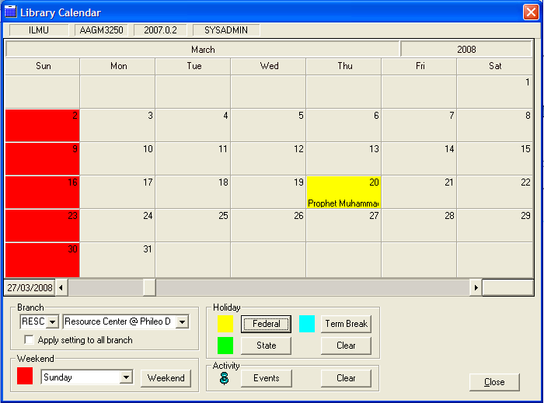

#### Highlighting State Holiday

**Steps**

1. Choose the date(s) to be highlighted as State Holiday.
2. In Holidaycolumn, click the **State** button.
3. A message will be prompted as shown in figure below. Enter appropriate description for State Holiday.

Figure 8.65: Prompt message

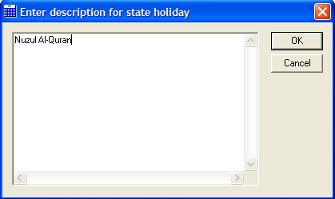

1. Click the **OK** button. System will mark the chosen date as federal holiday and highlighted in a green as shown in figure below.

Figure 8.66: Highlighted calendar for state holiday

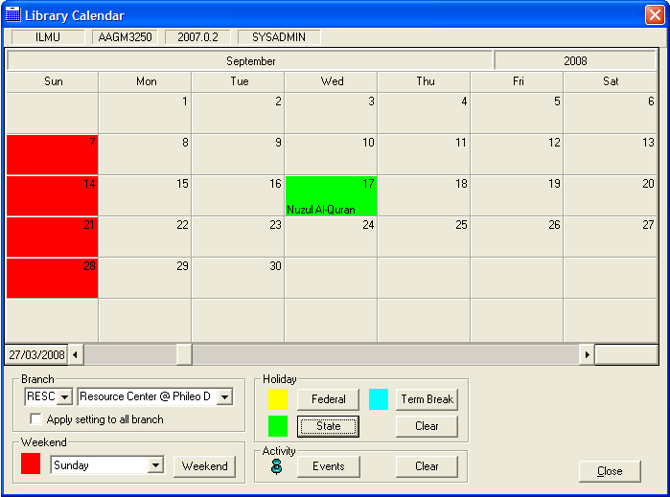

#### Highlighting Term Break

**Steps**

1. Choose the date(s) to be highlighted as Term Break.
2. In Holidaycolumn, click **Term Break** button.
3. A message will be prompted as shown in figure below. Enter appropriate description for Term Break.

Figure 8.67: Prompt message

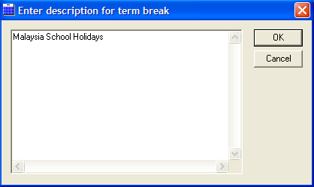

1. Click the **OK** button. System will mark the chosen dates as term break and highlighted in light blue as shown in figure below.

Figure 8.68: Highlighted calendar for term break

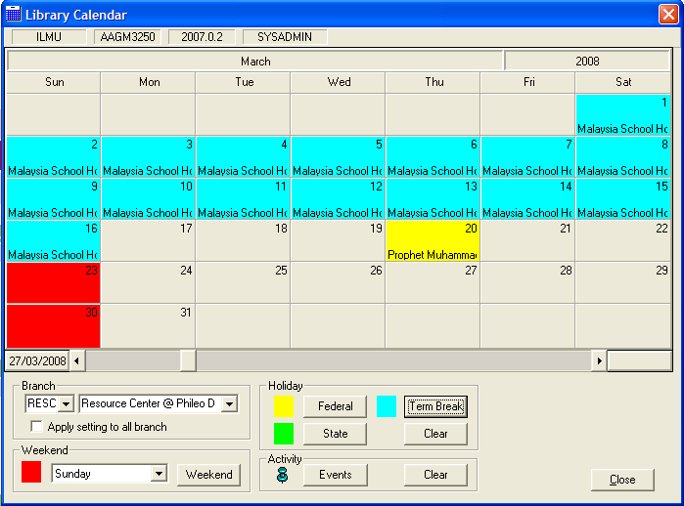

#### Highlighting Library Event

**Steps**

1. Choose the date(s) to be highlighted as library event.
2. In Activity column, click the **Events** button.
3. A message will be prompted as shown below. Enter appropriate description for library events.

Figure 8.69: Prompt message

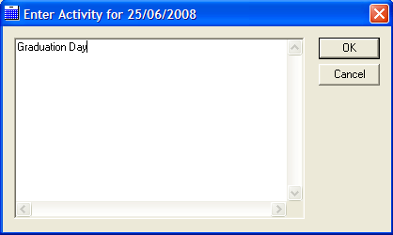

1. Click the **OK** button. System will mark the chosen dates as event with the thumbnails symbol as shown in figure below.

Figure 8.70: Marked date with thumbnail symbol

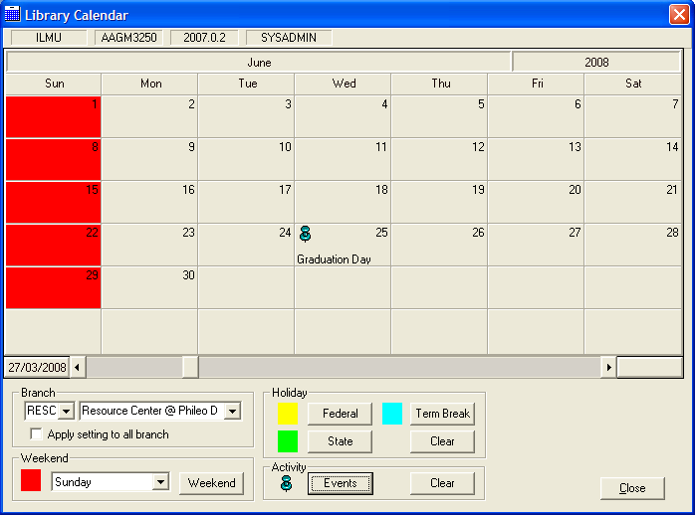

#### Delete Federal Holiday

**Steps**

1. To delete the Federal Holiday, choose the date(s) which highlighted as Federal Holiday (in yellow).
2. Click **Clear** button in the Holiday column.
3. The highlighted date will be cleared.

#### Delete State Holiday

**Steps**

1. To delete the State Holiday, choose the date(s) highlighted as State Holiday (in green).
2. Click **Clear** button in the Holiday column.
3. The highlighted date will be cleared.

#### Delete Term Break

**Steps**

1. To delete the Term Break, choose the date(s) highlighted as Term Break (in light blue).
2. Click **Clear** button in the Holiday column.
3. The highlighted date will be cleared.

#### Delete Event

**Steps**

1. To delete the Event, choose the date(s) marked in thumbnail symbol.
2. Click the **Clear** button in the Activity column.
3. The highlighted date will be cleared.

### Town Code

Town Code maintenance stored all the details about town code and town name.

**Steps**

1. Select **Foundation** module.
2. Click on **Maintenance** and then **Town Code**.
3. The screen will be displayed as shown in figure below.

Figure 8.71: Town Code dialog box

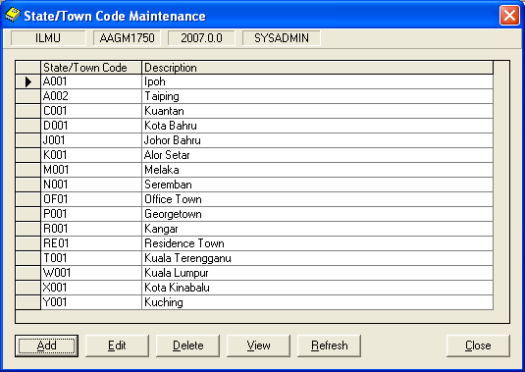

#### Add Town Code

**Steps**

1. From figure above, click on **Add** button. The following screen will be displayed.

Figure 8.72: Add Town Code dialog box

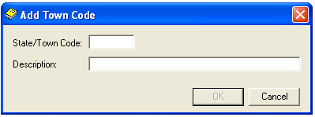

1. Enter the Town **Code** and **Description**. You can see the **OK** button will be enabled.
2. Click on **OK** button. The latest town code will be displayed in State/Town Code Maintenance.

#### View Town Code

**Steps**

1. Town Codes that have been created will be displayed. Highlight a row to view its details.
2. Click the **View** button. View Town Code dialog box will be displayed as below.

Figure 8.73: View Town Code dialog box

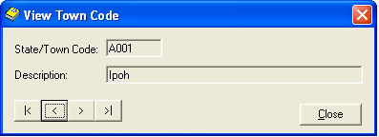

Vie the next or previous town code.

1. Click the **Close** button, to close the View Town Code dialog box.

#### Edit Town Code

**Steps**

1. Town Codes that have been created will be displayed. Highlight a row to edit its details.
2. Click the **Edit** button. Edit Town Code dialog box will be displayed as below.

Figure 8.74: Edit Town Code dialog box

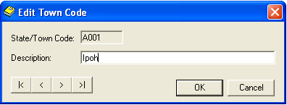

1. Click the **Edit** button. Edit Town Code dialog box will be displayed as below.
2. Make necessary amendments. **OK** button will be enabled.
3. Click on **OK** button.

#### Delete Town Code

**Steps**

Note **Note:**

Cannot delete the code which used by other records.

1. Town Codes that have been created will be displayed. Highlight a row to delete its details.
2. Click the **Delete** button. The message as below will be displayed.

Figure 8.75: Message prompt before deleting a record

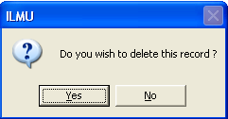

1. Click the **Yes** button. The highlighted record will be deleted.

Figure 8.76: Message prompt after deleting a record

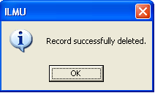

1. Click on **OK** button to close the dialog box.

#### Refresh Town Code

**Steps**

1. Click the **Refresh** button.
2. The **State/ Town Code Maintenance**dialog box will be refreshed.
3. Click on **Close** button to close the dialog box.

### Vendor Code

Vendor Code Maintenance stores the vendor details. The vendor details will be used in transactions for Acquisition and Serials modules.

**Steps**

1. Select **Foundation** module.
2. Click at **Maintenance** function and then click **Vendor Code** function.
3. The **Vendor Code Maintenance** dialog box will be appeared as shown in figure below.

Figure 8.77: Vendor Code Maintenance dialog box

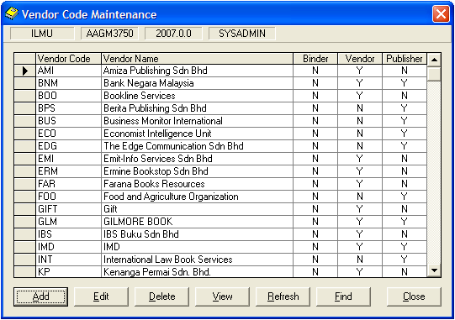

#### Add Vendor Details

**Steps**

* + - 1. From figure above, click the **Add**button. **Add Vendor Code**dialog box will be appeared as shown in figure below.

Figure 8.78: Add Vendor details dialog box

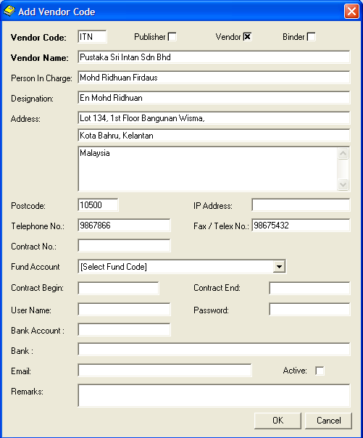

1. Fill in the related details. **Vendor Code** and **Vendor Name** are the mandatory fields.
2. Click the **OK** button. The latest vendor code created will be displayed in **Vendor Code Maintenance** dialog box.

#### Find existing Vendor Details

**Steps**

1. Click the **Find**button. You will see the **Find Criteria**dialog box as shown in figure below.

Figure 8.79: Find Criteria dialog box

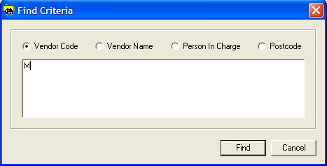

1. Choose search criteria by clicking the selected radio button. You can search the vendor details by :

* Vendor Code
* Vendor Name
* Person In Charge
* Postcode

1. Enter search term in the text area and click the **Find** button. The particular details will be displayed in Vendor Code Maintenance dialog box as shown in figure below.

Figure 8.80: Vendor Code Maintenance dialog box

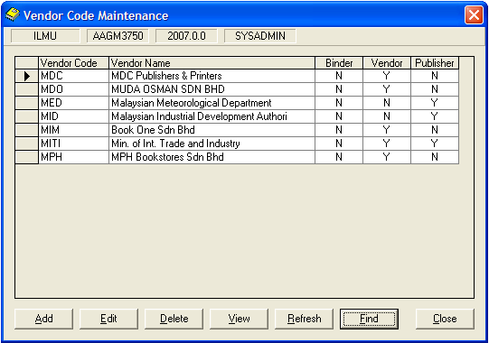

#### View Vendor Details

**Steps**

1. Vendor Codes that have been created will be displayed in the Vendor Code Maintenance dialog box. Highlight the row to view its details.
2. Click the **View** button. The **View Vendor Code** dialog box will be displayed as shown in figure below.

Figure 8.81: View Vendor Code dialog box

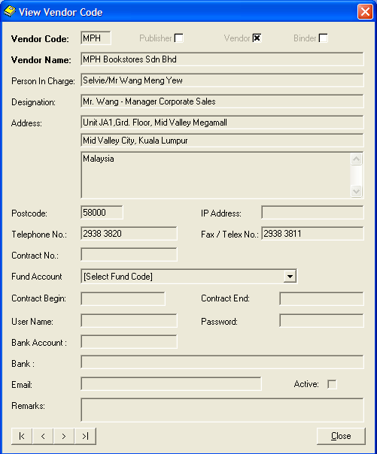

1. Click the **Close** button to close the dialog box.

#### Edit Vendor Details

**Steps**

1. Vendor Codes that have been created will be displayed in Vendor Code Maintenance. Highlight the row to edit its details.
2. Click **Edit** button. The **Edit Vendor Code** dialog box will be appeared as shown in figure below.

Figure 8.82: Edit Vendor Details dialog box

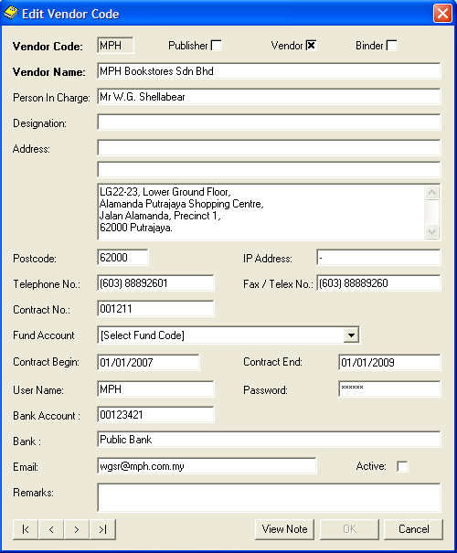

1. Make necessary amendments. Then, click the **OK** button.

#### Delete Vendor Details

**Steps**

1. Vendor Codes that have been created will be displayed in **Vendor Code Maintenance dialog** box. Highlight the row to delete its details. (Make sure the vendor code chosen is not being referred for any transactions)
2. Click the **Delete** button. The message will be appeared as shown in figure below.

Figure 8.83: Prompt message

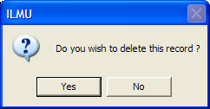

1. Click the **Yes** button. A successfully message will be appeared as shown in figure below. The highlighted record will be deleted.

Figure 8.84: Successful message

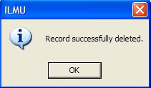

1. Click the **OK** button to complete the process.

#### Refresh Vendor Details

**Steps**

1. Click the **Refresh** button.
2. The entire **Vendor Code Maintenance**dialog box will be refreshed.
3. Click the **Close** button to close the dialog box.

### Currency Code

Currency Code maintenance stored all the details about currency code, description, publisher’s rate and bank rate for different countries.

**Steps**

1. Select **Foundation** module.
2. Click on **Maintenance** and then **Currency Code**.
3. The screen will be displayed as shown in figure below.

Figure 8.85: Currency Code dialog box

Tip **Tip :**

The system will automatically insert **/** while entering the date.

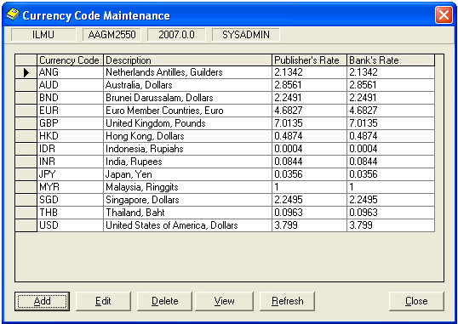

#### Add Currency Code

**Steps**

1. From figure above, click on **Add** button. The following screen will be displayed.

Figure 8.86: Add Currency Code dialog box

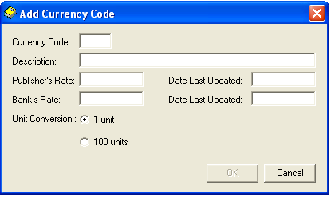

1. Fill the related details. You can see the **OK** button will be enabled after you have entered all the fields.
2. Click on the **OK** button.

#### View Currency Code

**Steps**

1. Currency Codes that have been created will be displayed. Highlight a row to view its details.
2. Click the **View** button. View Currency Code dialog box will be displayed as below.

Figure 8.87: View Currency Code dialog box

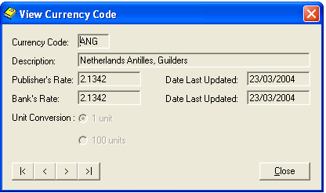

View the next or previous currency code.

1. Click the **Close** button, to close the View Currency Code dialog box.

#### Edit Currency Code

**Steps**

1. Currency Codes that have been created will be displayed. Highlight a row to edit its details.
2. Click the **Edit** button. Edit Currency Code dialog box will be displayed as below.

Note **Note:**

Cannot delete the code which used by other records.

Figure 8.88: Edit Currency Code dialog box

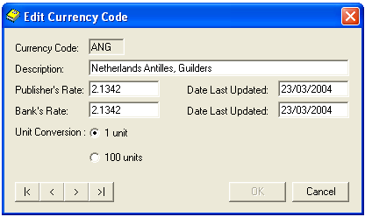

1. Click the **Edit** button. Edit Currency Code dialog box will be displayed as below.
2. Make necessary amendments. **OK** button will be enabled.
3. Click on **OK** button.

#### Delete Currency Code

**Steps**

1. Currency Codes that have been created will be displayed. Highlight a row to delete its details.
2. Click the **Delete** button. The message as below will be displayed.

Figure 8.89: Message prompt before deleting a record

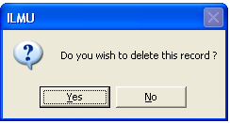

1. Click the **Yes** button. The highlighted record will be deleted.

Figure 8.90: Message prompt after deleting a record

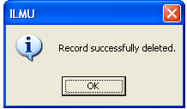

1. Click on **OK** button to close the dialog box.

#### Refresh Currency Code

**Steps**

1. Click the **Refresh** button.
2. The **Currency Code Maintenance**dialog box will be refreshed.
3. Click on **Close** button to close the dialog box.

### Item Category

Item Category Maintenance stores the Item Category details. This function will be used as part of maintenance in Patron Eligibility.

**Steps**

1. Select **Foundation** module.
2. Click on **Maintenance** and then **Item Category**.
3. The screen will be displayed as shown in figure below.

Figure 8.91: Item Category dialog box

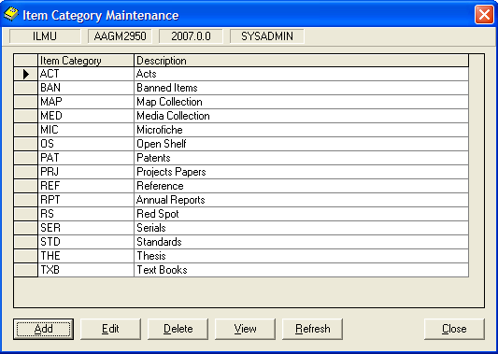

#### Add Item Category

**Steps**

1. From Item Category dialog box, click the **Add** button. **Add Item Category**dialog box will appear as shown in figure below.

Figure 8.92: Add Item Category dialog box

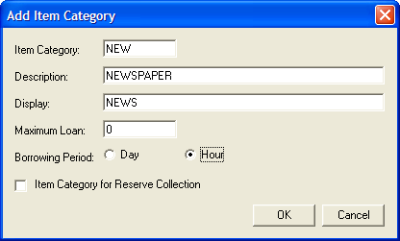

1. Fill in the related details.
2. Click the **OK** button. The latest Item Category created will be displayed in **Item Category Maintenance** dialog box.

#### View Item Category

**Steps**

1. Item Categories that have been created will be displayed in **Item Category Maintenance** dialog box. Highlight the row to view its details.
2. Click the **View** button. The **View Item Category** dialog box will be displayed as shown in figure below.

Figure 8.93: View Item Category dialog box

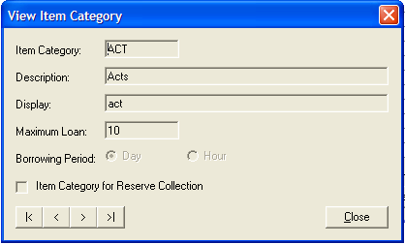

1. Click the **Close** button to close the **View Item Category** dialog box.

#### Edit Item Category

**Steps**

1. Item Categories that have been created will be displayed in **Item Category Maintenance** dialog box. Highlight the row to edit its details.
2. Click **Edit** button. The **Edit Item Category** dialog box will appear as shown in figure below.

Figure 8.94: Edit Item Category dialog box

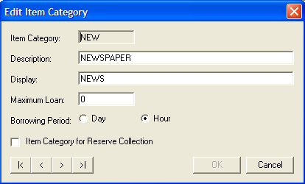

1. Make necessary amendments. Then, click the **OK** button.

#### Delete Item Category

**Steps**

1. Item Categories that have been created will be displayed in **Item Category Maintenance** dialog box. Highlight the row to delete its details.
2. Click **Delete** button. The message will be prompted as shown in figure below.

Figure 8.95: Prompt message

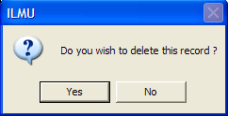

1. Click the **Yes** button. A successfully message will be appeared as shown in figure below. The highlighted record will be deleted.

Figure 8.96: Successful message



1. Click the **OK** button to complete the process.

#### Refresh Item Category

**Steps**

1. Click the **Refresh** button.
2. The entire **Item Category Maintenance**dialog box will be refreshed.
3. Click the **Close** button to close the dialog box.

### Condition Code

Condition Code maintenance stored the details about books condition.

**Steps**

1. Select **Foundation** module.
2. Click on **Maintenance** and then **Condition Code**.
3. The screen will be displayed as shown in figure below.

Figure 8.97: Condition Code dialog box

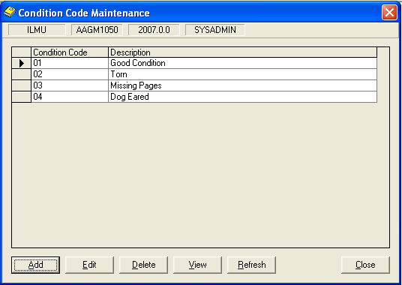

#### Add Condition Code

**Steps**

1. From figure above, click on **Add** button. The following screen will be displayed.

Figure 8.98: Add Condition Code dialog box

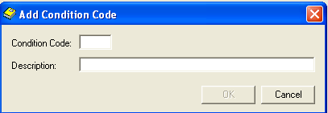

1. Fill the related details. You can see the **OK** button will be enabled after you have entered all the fields.
2. Click on the **OK** button.

#### View Condition Code

**Steps**

1. Condition Codes that have been created will be displayed. Highlight a row to view its details.
2. Click the **View** button. View Condition Code dialog box will be displayed as below.

Figure 8.99: View Currency Code dialog box

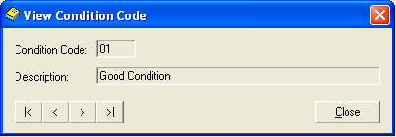

View the next or previous Condition Code.

1. Click the **Close** button, to close the View Condition Code dialog box.

#### Edit Condition Code

**Steps**

1. Condition Codes that have been created will be displayed. Highlight a row to edit its details.
2. Click the **Edit** button. Edit Condition Code dialog box will be displayed as below.

Figure 8.100: Edit Condition Code dialog box

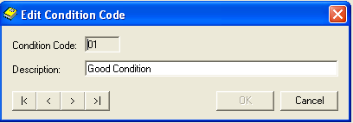

1. Click the **Edit** button. Edit Condition Code dialog box will be displayed as below.
2. Make necessary amendments. **OK** button will be enabled. Click on **OK** button.

Note **Note:**

Cannot delete the codes which used by other records.

#### Delete Condition Code

**Steps**

1. Condition Codes that have been created will be displayed. Highlight a row to delete its details.
2. Click the **Delete** button. The message as below will be displayed.

Figure 8.101: Message prompt before deleting a record



1. Click the **Yes** button. The highlighted record will be deleted.

Figure 8.102: Message prompt after deleting a record



1. Click on **OK** button to close the dialog box.

#### Refresh Condition Code

**Steps**

1. Click the **Refresh** button.
2. The **Condition Code Maintenance**dialog box will be refreshed.
3. Click on **Close** button to close the dialog box.

### Location Code

Location Code Maintenance stores the Location details.

**Steps**

1. Select **Foundation** module.
2. Click at **Maintenance** function and then click **Location Code** function.
3. The **Location Code Maintenance** dialog box will be appeared as shown in figure below.

Figure 8.103: Location Code Maintenance dialog box

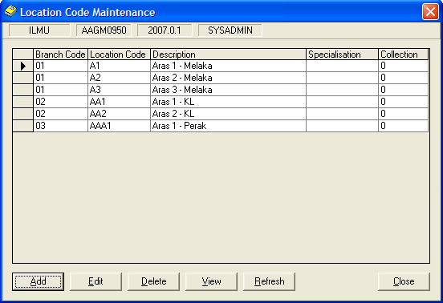

#### Add Location Code

**Steps**

1. From figure above, click the **Add** button. **Add Location Code** dialog box will appeared as shown in figure below.

Figure 8.104: Add Location Code dialog box

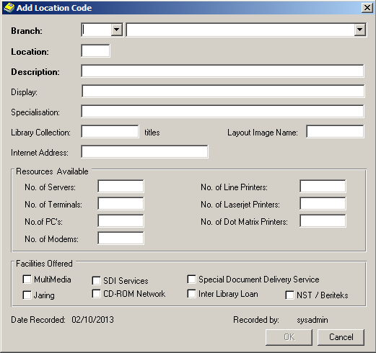

1. Fill in the related details. Click the **OK** button. The latest location code created will be displayed in **Location Code Maintenance** dialog box.

#### View Location Code

**Steps**

1. Location Code that has been created will be displayed in **Location Code Maintenance** dialog box. Highlight the row to view its details.
2. Click the **View** button. The **View Location Code** dialog box will be displayed as shown in figure below.

Figure 8.105: View Location Code dialog box

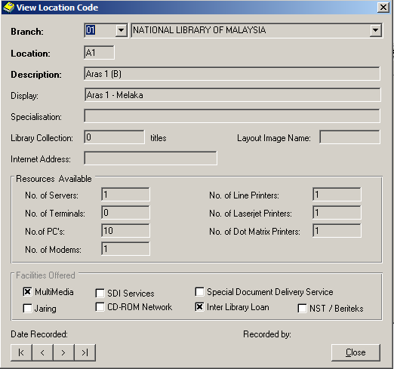

1. Click the **Close** button to close the **View Location Code** dialog box.

#### Edit Location Code

**Steps**

1. Location Code that has been created will be displayed in **Location Code Maintenance** dialog box. Highlight the row to edit its details.
2. Click **Edit** button. The **Edit Location Code** dialog box will appear as shown in figure below.

Figure 8.106: Edit Location Code dialog box

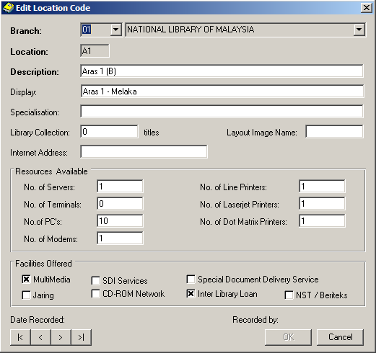

1. Make necessary amendments. Then, click the **OK** button.

#### Delete Location Code

**Steps**

1. Location Code that has been created will be displayed in **Location Code Maintenance** dialog box. Highlight the row to delete its details.
2. Click **Delete** button. The message will be prompted as shown in figure below.

Figure 8.107: Prompt message



1. Click the **Yes** button. A successfully message will be appeared as shown in figure below. The highlighted record will be deleted.

Figure 8.108: Successful message



1. Click the **OK** button to complete the process.

#### Refresh Location Code

**Steps**

1. Click the **Refresh** button.
2. The entire **Location Code Maintenance**dialog box will be refreshed.
3. Click the **Close** button to close the dialog box.

### Patron Category

Patron Category maintenance stored the details about patrons.

**Steps**

1. Select **Foundation** module.
2. Click on **Maintenance** and then **Patron Category**.
3. The screen will be displayed as shown in figure below.

Figure 8.109: Patron Category Maintenance dialog box

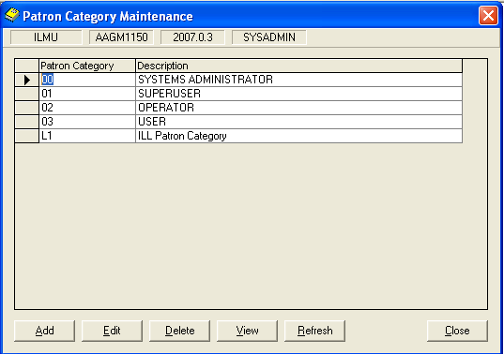

#### Add Patron

**Steps**

1. From figure above, click on **Add** button. The following screen will be displayed.

Figure 8.110: Add Patron Category dialog box

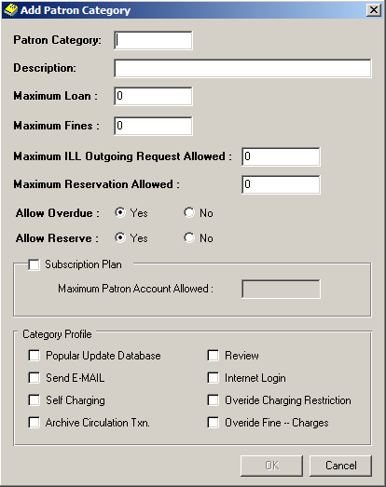

1. Fill the related details. You can see the **OK** button will be enabled after you have entered all the fields.
2. Click on the **OK** button.

#### View Patron Category

**Steps**

1. Patron Category that has been created will be displayed. Highlight a row to view its details.
2. Click the **View** button. View Patron Category dialog box will be displayed as below.

Figure 8.111: View Patron Category dialog box

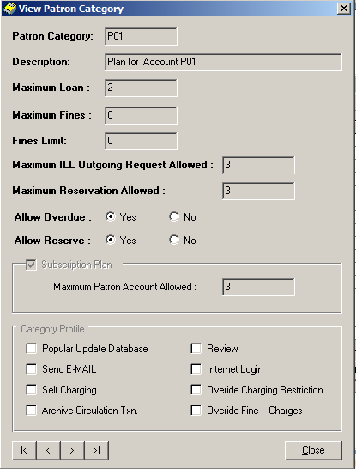

View the next or

previous patron

category.

1. Click the **Close** button, to close the View Patron Category dialog box.

#### Edit Patron Category

**Steps**

1. Patron Category that has been created will be displayed. Highlight a row to edit its details.
2. Click the **Edit** button. Edit Patron Category dialog box will be displayed as below.

Figure 8.112: Edit Patron Category dialog box

Note **Note:**

Cannot delete the codes which used by other records.

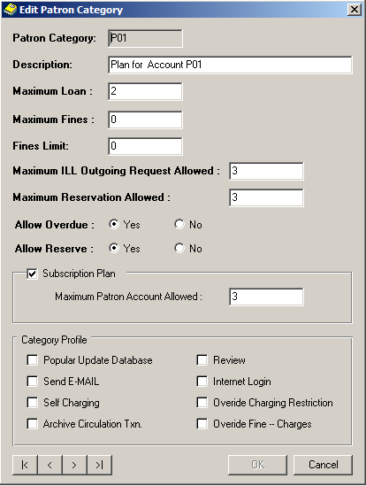

1. Click the **Edit** button. Edit Patron Category dialog box will be displayed as below.
2. Make necessary amendments. **OK** button will be enabled. Click on **OK** button.

#### Delete Patron Category

**Steps**

1. Patron Category that has been created will be displayed. Highlight a row to delete its details.
2. Click the **Delete** button. The message as below will be displayed.

Figure 8.113: Message prompt before deleting a record



1. Click the **Yes** button. The highlighted record will be deleted.

Figure 8.114: Message prompt after deleting a record



1. Click on **OK** button to close the dialog box.

#### Refresh Patron Category Maintenance

**Steps**

1. Click the **Refresh** button.
2. The **Patron Category Maintenance**dialog box will be refreshed.
3. Click on **Close** button to close the dialog box.

### Library Information

Library Information holds the details of the library. Library Name and Address will be used in every letter generated by ILMU whether from Circulation, Acquisition or Serials modules.

**Steps**

1. Select **Foundation** module.
2. Click on **Maintenance** and then **Library Information** function.
3. The screen will be displayed as shown in figure below.

Figure 8.115: Library Information Maintenance dialog box

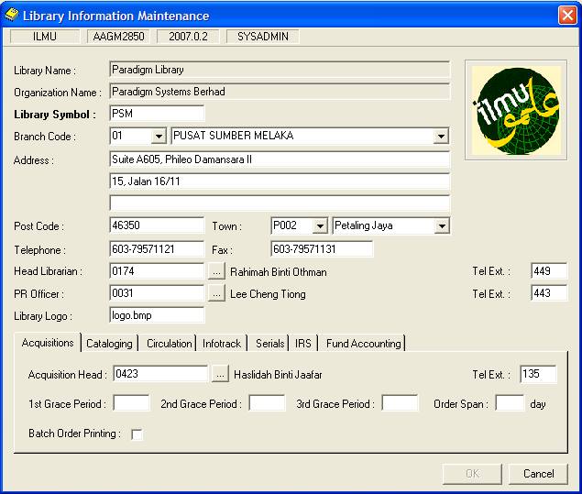

#### Add Library Information

**Steps**

1. From figure above, fill in the fields and columns in tabs with related details.
2. Click on **OK** button. The latest Library Information created will be saved.

#### Edit Library Information

**Steps**

1. Library Information that has been created will be displayed in **Location Information Maintenance** dialog box. Highlight the row to edit its details.
2. Click **Edit** button. The **Edit Library Information** dialog box will appear as shown in figure below.

Figure 8.116: Edit Library Information dialog box

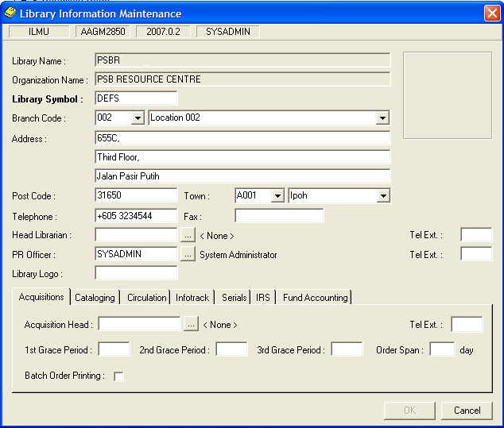

1. Make the necessary amendments. Click the **OK** button. A message will be displayed as shown in figure below.

Figure 8.117: Message record update

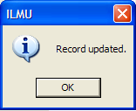

1. Click the **OK** button.

### Document Status

Document Status stored the document status and the description.

**Steps**

1. Select **Foundation** module.
2. Click on **Maintenance** and then **Document Status**.
3. The screen will be displayed as shown in figure below.

Figure 8.118: Document Status Maintenance dialog box

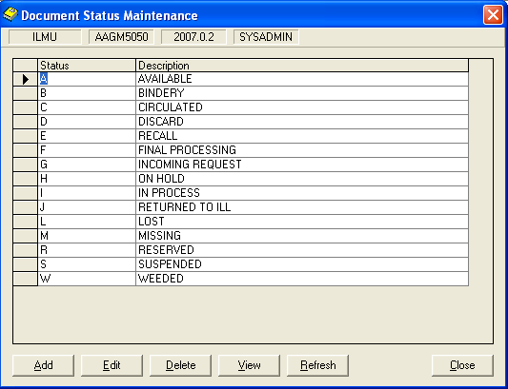

#### Add Document Status

**Steps**

1. From figure above, click on **Add** button. The following screen will be displayed.

Figure 8.119: Add Document Status dialog box

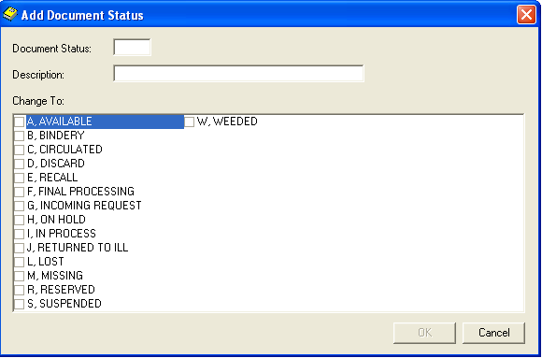

1. Fill the related details. You can see the **OK** button will be enabled after you have entered all the fields.
2. Click on the **OK** button.

#### View Document Status

**Steps**

1. Document Status that has been created will be displayed. Highlight a row to view its details.
2. Click the **View** button. View Document Status dialog box will be displayed as below.

Figure 8.120: View Document Status dialog box

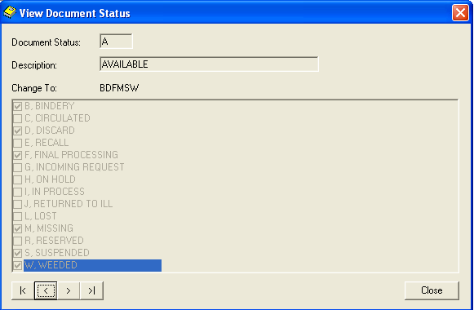

View the next or previous document status.

1. Click the **Close** button, to close the View Document Status dialog box.

#### Edit Document Status

**Steps**

1. Document Status that has been created will be displayed. Highlight a row to edit its details.
2. Click the **Edit** button. Edit Document Status dialog box will be displayed as below.

Figure 8.121: Edit Document Status dialog box

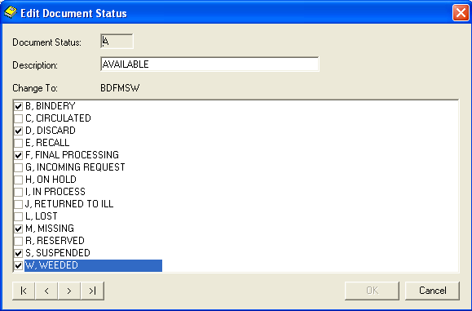

1. Click the **Edit** button. Edit Document Status dialog box will be displayed as below.
2. Make necessary amendments. **OK** button will be enabled. Click on **OK** button.

#### Delete Document Status

Note **Note:**

Cannot delete the codes which used by other records.

**Steps**

1. Document Status that has been created will be displayed. Highlight a row to delete its details.
2. Click the **Delete** button. The message as below will be displayed.

Figure 8.122: Message prompt before deleting a record

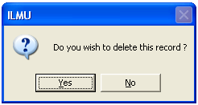

1. Click the **Yes** button. The highlighted record will be deleted.

Figure 8.123: Message prompt after deleting a record

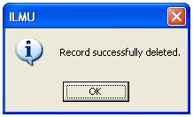

1. Click on **OK** button to close the dialog box.

#### Refresh Condition Code

**Steps**

1. Click the **Refresh** button.
2. The **Document Status Maintenance**dialog box will be refreshed.
3. Click on **Close** button to close the dialog box.

### Specific Material Designation (SMD)

SMD Maintenance function is to maintain the details of Specific Material Designation.

**Steps**

1. Select **Foundation** module.
2. Click on **Maintenance** and then **Specific Material Designation (SMD)** function.
3. The screen will be displayed as shown in figure below.

Figure 8.124: Specific Material Designation (SMD) Maintenance dialog box

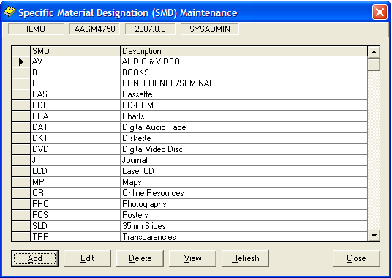

#### Add Specific Material Designation (SMD)

**Steps**

1. From figure above, click the **Add** button. **Add SMD** dialog box will be appeared as shown in figure below.

Figure 8.125: Add SMD dialog box

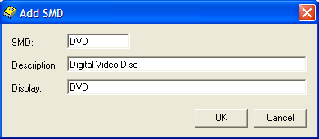

1. Fill in the related details.
2. Click the **OK** button. The latest SMD created will be displayed in **Specific Material Designation (SMD) Maintenance** dialog box.

#### View Specific Material Designation (SMD)

**Steps**

1. Specific Material Designation (SMD) that has been created will be displayed in **Specific Material Designation (SMD**) **Maintenance** dialog box. Highlight the row to view its details.
2. Click the **View** button. The **View SMD** dialog box will be displayed as shown in figure below.

Figure 8.126: View SMD dialog box

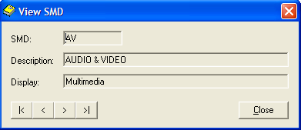

#### Edit Specific Material Designation (SMD)

**Steps**

1. Specific Material Designation (SMD) that has been created will be displayed in **Specific Material Designation (SMD)** **Maintenance** dialog box. Highlight the row to edit its details.
2. Click **Edit** button. The **Edit SMD** dialog box will appear as shown in figure below.

Figure 8.127: Edit SMD

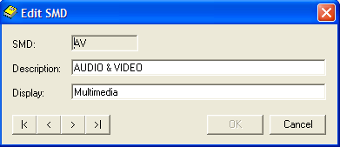

1. Make necessary amendments. Then, click the **OK** button.

#### Delete Specific Material Designation (SMD)

**Steps**

1. Specific Material Designation (SMD) that has been created will be displayed in **Specific Material Designation (SMD) Maintenance** dialog box. Highlight the row to delete its details.
2. Click **Delete** button. The message will be prompted as shown in figure below.

Figure 8.128: Prompt message



1. Click the **Yes** button. A successfully message will be appeared as shown in figure below. The highlighted record will be deleted.

Figure 8.129: Successful message



1. Click the **OK** button to complete the process.

#### Refresh Specific Material Designation (SMD)

**Steps**

1. Click the **Refresh** button.
2. The entire **Specific Material Designation (SMD)** **Maintenance**dialog box will be refreshed.
3. Click the **Close** button to close the dialog box.

### Tag Parameter

Tag Parameter Maintenance maintains the details of tag parameters.

**Steps**

1. Select **Foundation** module.
2. Click on **Maintenance** and then **Tag Parameter**
3. The screen will be displayed as shown in figure below.

#### Add Tag Parameter

**Steps**

1. In **Record** menu, choose **Add** or click on  icon.
2. **Add Tag Parameter** screen will appear as below.

Figure 8.130: Add Tag Parameter dialog box

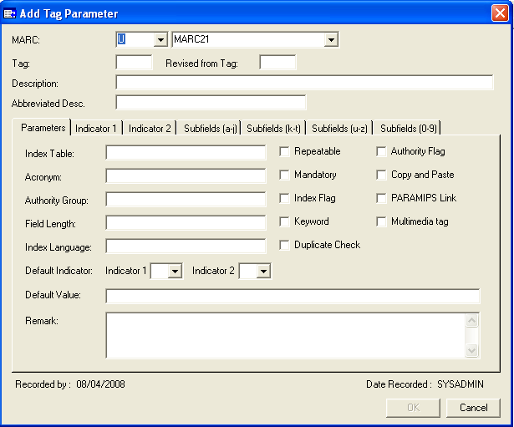

1. Fill in the related details. Notice the **OK** button is disabled.
2. Click on **OK** button to save the Tag Parameter. If you wish to about this process, just click **Cancel** and the information will not be saved.

#### Retrieve Tag Parameter

**Steps**

1. In **Record** menu, choose **Find** or click on  icon.
2. You will see **Search Criteria** screen will appear as below.

Figure 8.131: Search Criteria dialog box

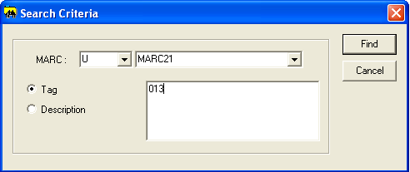

1. Choose a search criterion by clicking the selected radio button. Whether you want search using Tag or Description.
2. Enter the search criteria in the text area. Click on the **Find** button.
3. The search result will be displayed as below.

Figure 8.132: Search Result dialog box

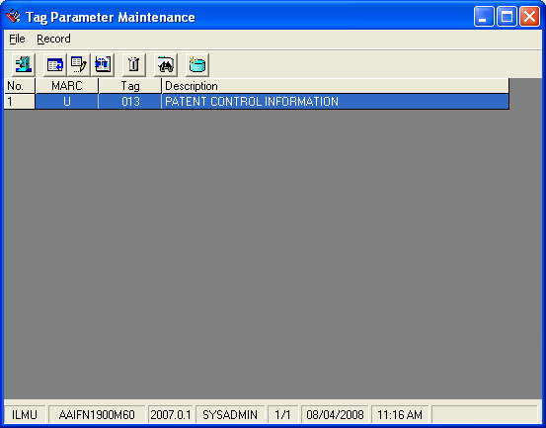

#### View Tag Parameter

**Steps**

1. Before viewing a particular tag parameter, first retrieve the record. Highlight a row to view its details.
2. After that in **Record** menu, choose **View** or click on  icon.
3. View Patron Details dialog box will be displayed.

Figure 8.133: View Patron Details dialog box

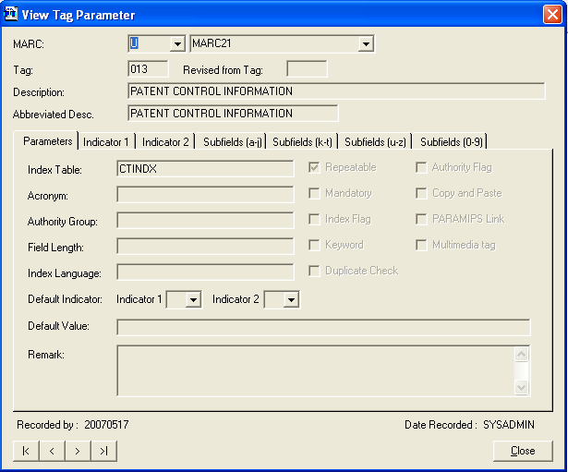

Browse Tag Parameter

1. Click the **Close** button to close the View Tag Parameterdialog box.

#### Edit Tag Parameter

**Steps**

1. Retrieve the tag parameter record before editing the particular record. Highlight a row to edit its details.
2. After that in **Record** menu, choose **Edit** or click on  icon.
3. Edit Patron Tag Parameter dialog box will be displayed.

Note **Note:**

Some of the records cannot be deleted because it’s have been using by other programs.

Figure 8.134: Edit Tag Parameter dialog box

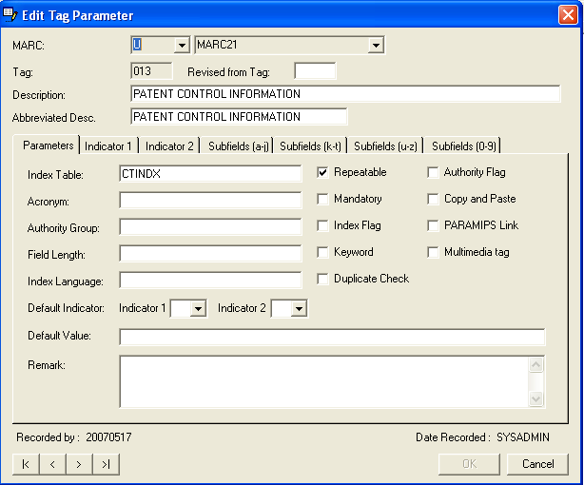

1. Make necessary amendments. Click **OK** button.

#### Delete Tag Parameter

**Steps**

1. Retrieve Tag Parameter details that you want to delete. Highlight a row to delete its details.
2. After that in **Record** menu, choose **Delete** or click on  icon.
3. Delete Tag Parameter dialog box will be display as below.

Figure 8.135: Delete Tag Parameter dialog box

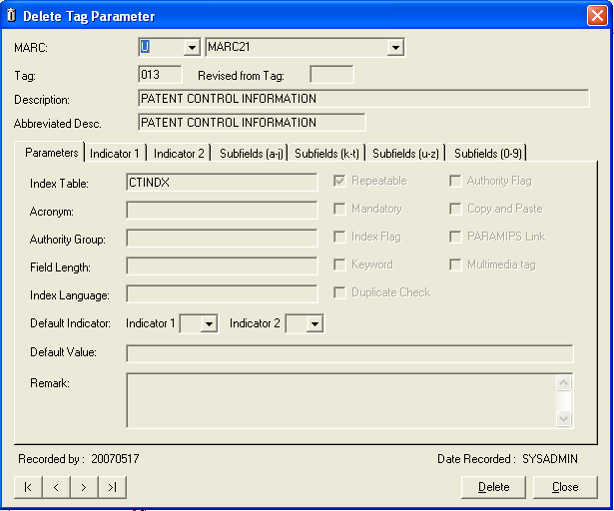

1. Click on **Delete** button.

Figure 8.136: Message prompt before deleting Tag Parameter



1. Click on **Yes** button to continue with deletion.
2. Click on **No** buttonto cancelthe deletion process.
3. If you successfully delete the tag parameter, a message prompts as below.

Figure 8.137: Message prompt after deleting Tag Parameter



#### Refresh Tag Parameter

**Steps**

1. Retrieve Tag Parameter.
2. In the **Record** menu, choose **Refresh** or click on icon.
3. The Tag Parameter dialog box will be refreshed.

### Group ID

Group ID Maintenance stores the Group ID details.

**Steps**

1. Select **Foundation** module.
2. Click on **Maintenance** and then click the **Group ID** function.
3. The screen will be displayed as shown in figure below.

Figure 8.138: Group ID Maintenance

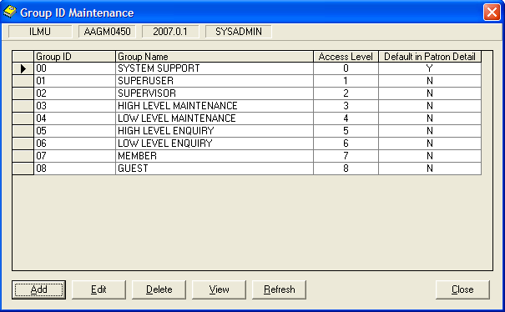

#### Add Group ID

**Steps**

1. From figure above, click the **Add** button. **Add Group ID** dialog box will be appeared as shown in figure below.

Figure 8.139: Add Group ID dialog box

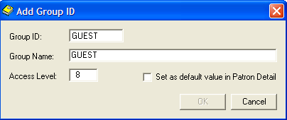

1. Fill in the related details.
2. Click the **OK** button. The latest Group ID created will be displayed in **Group ID Maintenance** dialog box.

#### View Group ID

**Steps**

1. Group ID that has been created will be displayed in **Group ID Maintenance** dialog box. Highlight the row to view its details.
2. Click the **View** button. The **View Group ID** dialog box will be displayed as shown in figure below.

Figure 8.140: View Group ID dialog box

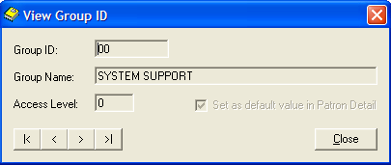

#### Edit Group ID

**Steps**

1. Group ID) that has been created will be displayed in **Group ID** **Maintenance** dialog box. Highlight the row to edit its details.
2. Click **Edit** button. The **Edit Group ID** dialog box will appear as shown in figure below.

Figure 8.141: Edit Group ID



1. Make necessary amendments. Then, click the **OK** button.

#### Delete Group ID

**Steps**

1. Group ID that has been created will be displayed in **Group ID Maintenance** dialog box. Highlight the row to delete its details.
2. Click **Delete** button. The message will be prompted as shown in figure below.

Figure 8.142: Prompt message



1. Click the **Yes** button. A successfully message will be appeared as shown in figure below. The highlighted record will be deleted.

Figure 8.143: Successful message



1. Click the **OK** button to complete the process.

#### Refresh Group ID

**Steps**

1. Click the **Refresh** button.
2. The entire **Group ID** **Maintenance**dialog box will be refreshed.
3. Click the **Close** button to close the dialog box.

### Patron Status

Patron Status Maintenance stored patron status details.

**Steps**

1. Select **Foundation** module.
2. Click on **Maintenance** and then **Patron Status.**
3. The screen will be displayed as shown in figure below.

Figure 8.144: Patron Status Maintenance dialog box

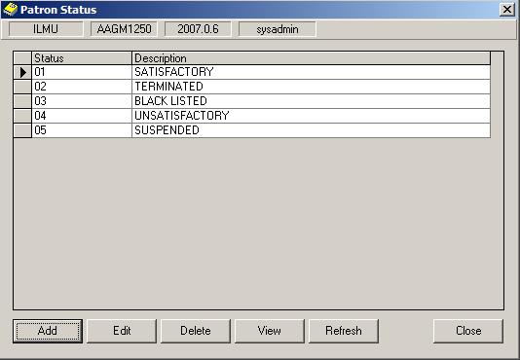

#### Add Patron Status

**Steps**

1. From figure above, click on **Add** button. The following screen will be displayed.

Figure 8.145: Add Patron Status dialog box

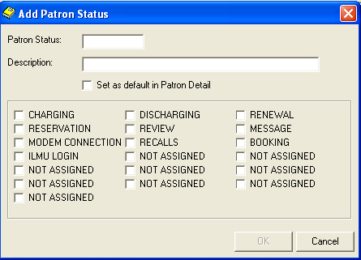

1. Fill the related details. You can see the **OK** button will be enabled after you have entered all the fields.
2. Click on the **OK** button.

#### View Patron Status

**Steps**

1. Patron Status that has been created will be displayed. Highlight a row to view its details.
2. Click the **View** button. View Patron Category dialog box will be displayed as below.

Figure 8.146: View Patron Status dialog box

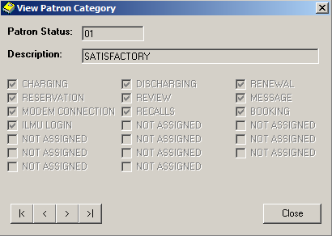

View the next or previous patron

category.

1. Click the **Close** button, to close the View Patron Status dialog box.

#### Edit Patron Status

**Steps**

1. Patron Status that has been created will be displayed. Highlight a row to edit its details.
2. Click the **Edit** button. Edit Patron Status dialog box will be displayed as below.

Figure 8.147: Edit Patron Status dialog box

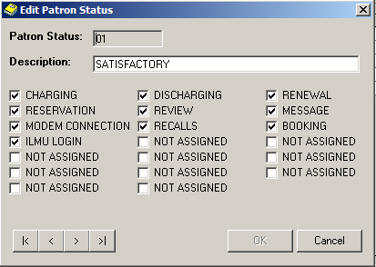

Note **Note:**

Cannot delete the codes which used by other records.

1. Click the **Edit** button. Edit Patron Status dialog box will be displayed as below.
2. Make necessary amendments. **OK** button will be enabled. Click on **OK** button.

#### Delete Patron Status

**Steps**

1. Patron Status that has been created will be displayed. Highlight a row to delete its details.
2. Click the **Delete** button. The message as below will be displayed.

Figure 8.148: Message prompt before deleting a record

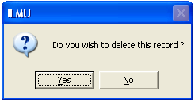

1. Click the **Yes** button. The highlighted record will be deleted.

Figure 8.149: Message prompt after deleting a record

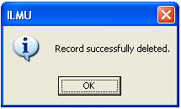

1. Click on **OK** button to close the dialog box.

#### Refresh Patron Status Maintenance

**Steps**

1. Click the **Refresh** button.
2. The **Patron Status Maintenance**dialog box will be refreshed.
3. Click on **Close** button to close the dialog box.

### MARC Type

MARC Type Maintenance stores the various MARC details.

**Steps**

1. Select **Foundation** module.
2. Click on **Maintenance** and then click the **MARC Type**.
3. The screen will be displayed as shown in figure below.

Figure 8.150: MARC Type Maintenance dialog box

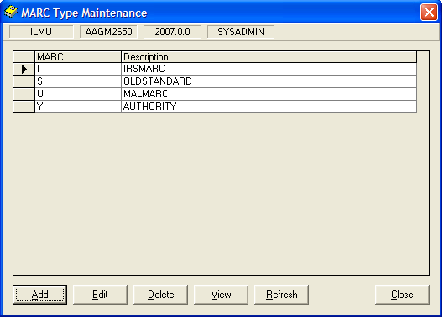

#### Add MARC Type

**Steps**

1. From figure above, click the **Add**button. The **Add MARC Type**dialog box will be displayed as shown in figure below.

Figure 8.151: Add Marc Type dialog box

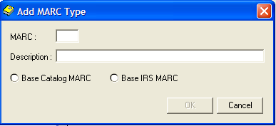

1. Fill in the related details in a text box.
2. Select option for MARC base by clicking on the radio button.
3. Then, click the **OK** button. The created record will be displayed in MARC Type Maintenance dialog box.
4. Otherwise, you can click on **Cancel** button to cancel the process.

#### Edit MARC Type

**Steps**

1. MARC Types that have been created will be displayed. Highlight a row to edit its details.
2. Click **Edit** button. The **Edit MARC Type** dialog box will appear.

Figure 8.152: Edit MARC Type dialog box

View the next or previous record(s).

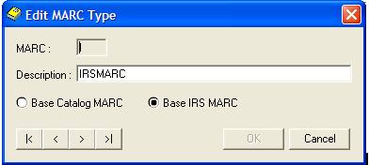

1. Make necessary amendments.
2. Click the **OK** button. The record will be updated in MARC Type Maintenance dialog box.
3. You can edit the other record(s) by clicking on Next and Previous button as shown in figure above.
4. Otherwise, you can click on **Cancel** button to cancel the process.

#### View MARC Type

**Steps**

1. MARC Types that have been created will be displayed in MARC Type Maintenance dialog box. Highlight a row to view its details.
2. Click the **View** button. The **View MARC Type** dialog box will be displayed as shown in figure below.

Figure 8.153: View MARC Type dialog box

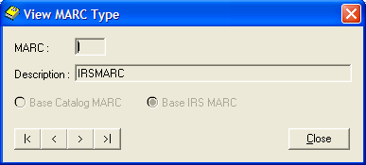

View the next or previous record(s).

1. You can view the other record(s) by clicking on Next and Previous button as shown in figure above.
2. Click the **Close** button to close the **View MARC Type** dialog box.

#### Delete MARC Type

**Steps**

1. MARC Types that have been created will be displayed in MARC Type Maintenance dialog box. Highlight the row to delete its details.
2. Click the **Delete** button. The message will be prompted as shown in figure below.

Figure 8.154: Prompt message

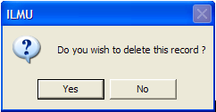

1. Click the **Yes** button. A successfully message will be appeared as shown in figure below. The record has been successfully deleted.

Figure 8.155: Successful message

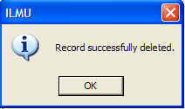

1. Click the **OK** button to complete the process.

#### Refresh MARC Type

**Steps**

* + - 1. Click the **Refresh** button.
      2. The entire **MARC Type Maintenance**dialog box will be refreshed.
      3. Click on **Close** button to close the dialog box.

### Bibliographic Source Code

Bibliographic Source Code stored the details about the bibliographic source and the description.

**Steps**

1. Select **Foundation** module.
2. Click on **Maintenance** and then **Bibliographic Source Code.**
3. The screen will be displayed as shown in figure below.

Figure 8.156: Bibliographic Source Code dialog box

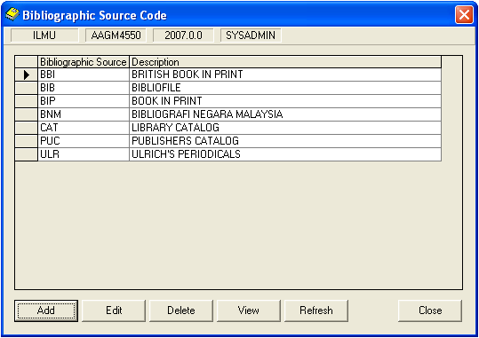

#### Add Bibliographic Source Code

**Steps**

1. From figure above, click on **Add** button. The following screen will be displayed.

Figure 8.157: Add Bibliographic Source Code dialog box

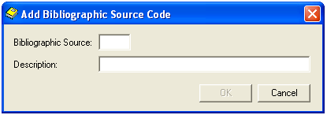

1. Fill the related details. You can see the **OK** button will be enabled after you have entered all the fields.
2. Click on the **OK** button.

#### View Bibliographic Source Code

**Steps**

1. Bibliographic Source Code that has been created will be displayed. Highlight a row to view its details.
2. Click the **View** button. View Bibliographic Source Code dialog box will be displayed as below.

Figure 8.158: View Bibliographic Source Code dialog box

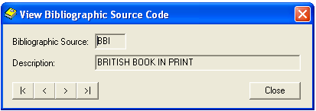

View the next or previous Bibliographic Source Code

1. Click the **Close** button, to close the View Bibliographic Source Code dialog box.

Note **Note:**

Cannot delete the codes which used by other records.

#### Edit Bibliographic Source Code

**Steps**

1. Bibliographic Source Code that has been created will be displayed. Highlight a row to edit its details.
2. Click the **Edit** button. Edit Bibliographic Source Code dialog box will be displayed as below.

Figure 8.159: Edit Bibliographic Source Code dialog box

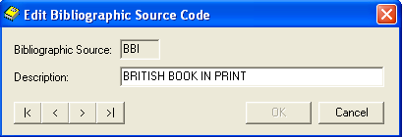

1. Make necessary amendments. **OK** button will be enabled. Click on **OK** button.

#### Delete Bibliographic Source Code

**Steps**

1. Bibliographic Source Code that has been created will be displayed. Highlight a row to delete its details.
2. Click the **Delete** button. The message as below will be displayed.

Figure 8.160: Message prompt before deleting a record



1. Click the **Yes** button. The highlighted record will be deleted.

Figure 8.161: Message prompt after deleting a record



1. Click on **OK** button to close the dialog box.

#### Refresh Bibliographic Source Code

**Steps**

1. Click the **Refresh** button.
2. The **Bibliographic Source Code**dialog box will be refreshed.
3. Click on **Close** button to close the dialog box.

### General Subject

General Subject stores the various General Subject details.

**Steps**

1. Select **Foundation** module.
2. Click on **Maintenance** and then click the **General Subject**.
3. The screen will be displayed as shown in figure below.

Figure 8.162: General Subject Maintenance dialog box

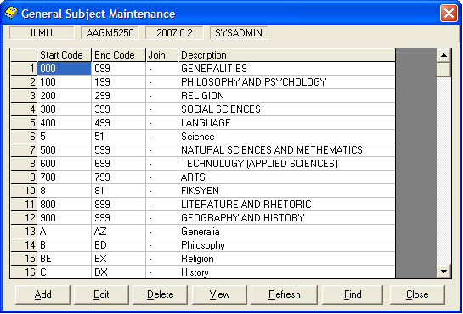

#### Add General Subject

**Steps**

1. From figure above, click the **Add**button. The **Add General Subject** dialog box will be displayed as shown in figure below.

Figure 8.163: Add General Subject dialog box

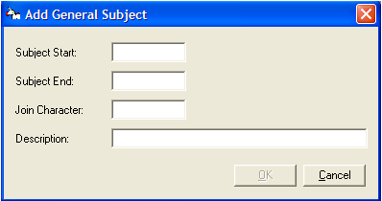

1. Fill in the related details in a text box.
2. Then, click the **OK** button. The created record will be displayed in General Subject Maintenance dialog box.
3. Otherwise, you can click on **Cancel** button to cancel the process.

#### Find General Subject

**Steps**

From General Subject Maintenance dialog box, click the **Find** button. You will see the **Search Criteria**dialog box display as shown in figure below.

Figure 8.164: Search Criteria dialog box

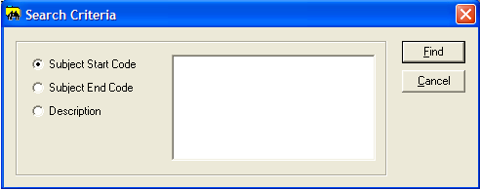

Choose search criteria by clicking the selected radio button. You can choose the criteria by:

* Subject Start Code
* Subject End Code
* Description

1. Enter search term in the text area and then, click the **Find** button. The screen will display the related general subjects in General Subject Maintenance dialog box.

#### Edit General Subject

**Steps**

1. The record(s) that have been created will be displayed in General Subject Maintenance dialog box. Highlight the row to edit its details.
2. Click the **Edit** button. The **Edit General Subject**dialog box will be appeared as shown in figure below.

Figure 8.165: Edit General Subject dialog box

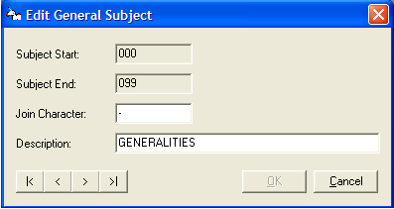

1. Make necessary amendments.
2. Click the **OK** button. The record will be updated in General Subject Maintenance dialog box.
3. You can edit the other record(s) by clicking on Next and Previous button as shown in figure above.
4. Otherwise, you can click on **Cancel** button to cancel the process.

#### View General Subject

**Steps**

1. The record(s) that have been created will be displayed in General Subject Maintenance dialog box. Highlight a row to view its details.
2. Click the **View** button*.* The**View General Subject**dialog box will be displayed as shown in figure below.

Figure 8.166: View General Subject dialog box

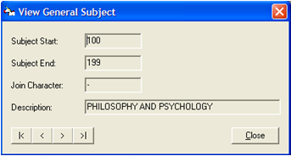

1. Click the **Close** button to close the **View General Subject**dialog box.

#### Delete General Subject

**Steps**

1. The record(s) that have been created will be displayed in General Subject dialog box. Highlight the row to delete its details.
2. Click the **Delete** button. The **Delete General** Subject dialog box will be appeared in a following screen.

Figure 8.167: Delete General Subject dialog box

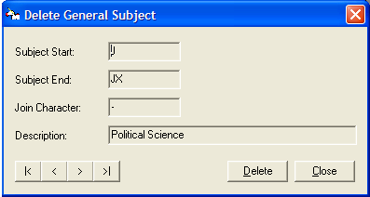

1. Click the **Delete** button. The message will be prompted as shown in figure below.

Figure 8.168: Prompt message

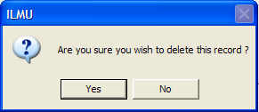

1. Click the **Yes** button. A successfully message will be appeared as shown in figure below. The record has been successfully deleted.

Figure 8.169: Successful message

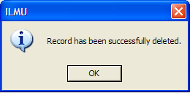

1. Click the **OK** button to complete the process.

#### Refresh General Subject

**Steps**

1. Click the **Refresh** button.
2. The entire **General Subject Maintenance** dialog box will be refreshed.
3. Click on **Close** button to close the dialog box.

### Semester Code

Semester Code Maintenance stored all the details about code semester and the description.

**Steps**

1. Select **Foundation** module.
2. Click on **Maintenance** and then **Semester Code.**
3. The screen will be displayed as shown in figure below.

#### Add Semester Code

**Steps**

1. From figure above, click on **Add** button. The following screen will be displayed.

Figure 8.170: Add Semester Code dialog box

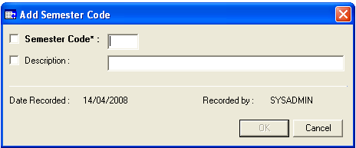

1. Fill the related details. You can see the **OK** button will be enabled after you have entered all the fields.
2. Click on the **OK** button.

#### Find Semester Code

**Steps**

1. Click on Find button in **Semester Code Maintenance** dialog box.
2. The figure below will be displayed.

Figure 8.171: Find Semester Code dialog box

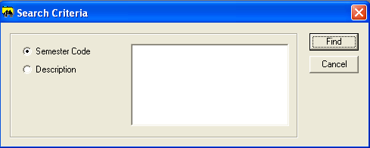

1. Choose either one of the option button, enter the search term and click on the **Find** button.
2. The search item will be displayed as below.

Figure 8.172: Displaying the search Item

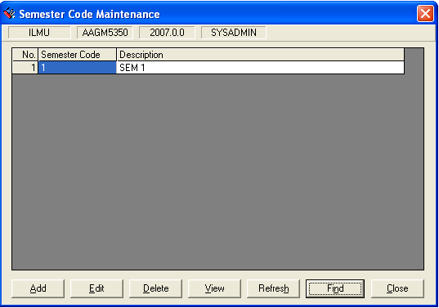

#### View Semester Code

**Steps**

1. Highlight the row to want to view.
2. Click the **View** button. View Semester Code dialog box will be displayed as below.

Figure 8.173: View Semester Code dialog box

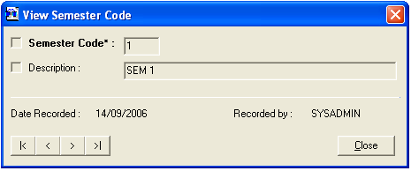

View the next or previous Semester Code

1. Click the **Close** button, to close the View Semester Code dialog box.

#### Edit Semester Code

**Steps**

1. Highlight a row to edit its details.
2. Click the **Edit** button. Edit Semester Code dialog box will be displayed as below.

Figure 8.174: Edit Semester Code dialog box

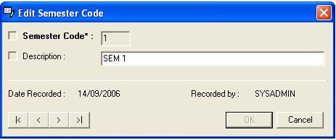

1. Make necessary amendments. **OK** button will be enabled. Click on **OK** button.

Note **Note:**

Cannot delete the codes which used by other records.

#### Delete Semester Code

**Steps**

1. Highlight a row to delete its details.
2. Click the **Delete** button. The message as below will be displayed.

Figure 8.175: Message prompt before deleting a record

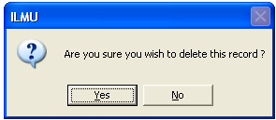

1. Click the **Yes** button. The highlighted record will be deleted.

Figure 8.176: Message prompt after deleting a record



1. Click on **OK** button to close the dialog box.

#### Refresh Semester Code

**Steps**

1. Click the **Refresh** button.
2. The **Semester Code**dialog box will be refreshed.
3. Click on **Close** button to close the dialog box.

### Academic Subject

Academic Subject Maintenance stores the various academic subject details.

**Steps**

1. Select **Foundation** module.
2. Click on **Maintenance** and then click the **Academic Subject** function.
3. The screen will be displayed as shown in figure below.

Figure 8.177: Academic Subject Maintenance

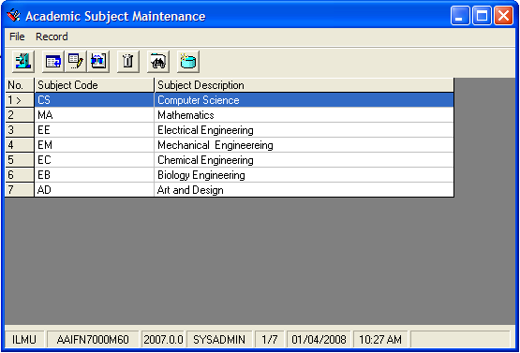

#### Add Academic Subject

**Steps**

1. From figure above, click on **Record** in tab menu*,* and choose **Add**, or
2. You can click on add icon,  to add the new Academic Subject.
3. The**Add Academic Subject**dialog box will be appeared as shown in figure below.

Figure 8.178: Add Academic Subject dialog box

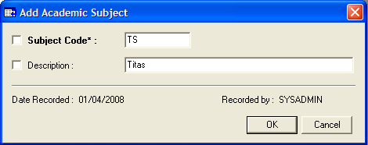

* + - 1. Fill in the related details.
      2. Click the **OK** button. The latest subject created will be displayed in **Academic Subject Maintenance** dialog box.
      3. Otherwise, you can click on **Cancel** button to cancel the process.

#### Find Existing Academic Subject

**Steps**

* + - 1. To find the existing Academic Subject record(s), click on **Record**tab and choose **Find** or
      2. Click on find icon,  in a screen to find the record(s)*.*  The **Search Criteria**dialog box will be appeared as shown in figure below.

Search term

Figure 8.179: Search criteria dialog box

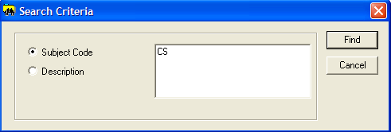

* + - 1. Choose search criteria by clicking a radio button. You can choose the criteria by:
* Subject Code
* Description
  + - 1. Enter search term and click on **Find** button. The screen will display the related Academic Subject sets as shown in figure below.

Figure 8.180: Search Result

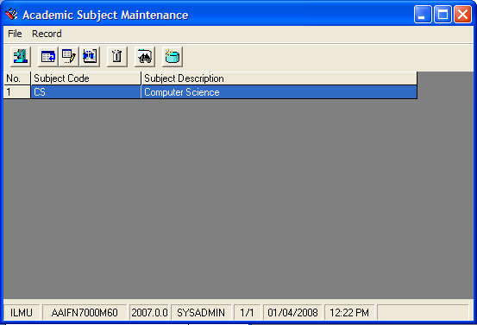

#### View Academic Subject

**Steps**

1. Click on **Record**tab and choose **View**, or
2. You can click the view icon*,*  to view the selected record. The **View Academic Subject** dialog box will be appeared as shown in figure below.

Figure 8.181: View Academic Subject dialog box

View the next or previous record(s).

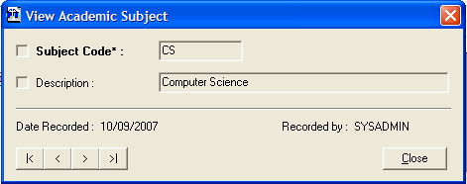

1. You can view the other record(s) by clicking on Next and Previous button as shown in figure above.
2. Then, click the **Close** button to close the View Academic Subjectwindow.

#### Edit Academic Subject

**Steps**

1. Academic Subject that has been created will be displayed in Academic Subject Maintenance dialog box. Highlight the row to edit its details.
2. Click on **Record**tab and choose **Edit**, or you can click the edit icon*,* .
3. The **Edit Academic Subject** dialog box will be appeared as show in figure below.

Figure 8.182: Edit Academic Subject dialog box

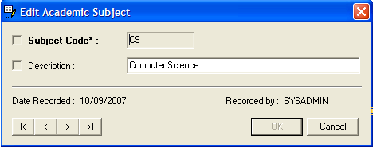

1. Make necessary amendments.
2. Then, click the **OK** button. The record will be updated in **Academic Subject Maintenance** dialog box.

#### Delete Academic Subject

**Steps**

1. From Academic Subject Maintenance dialog box, highlight the row to delete Academic Subject details.
2. Click on **Record**tab and choose **Delete**, or you can click the delete icon*,* .
3. The screen will be displayed as shown in figure below.

Figure 8.183: Delete Academic Subject dialog box

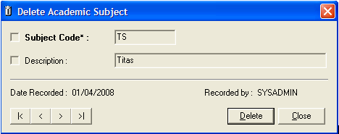

1. Click on **Delete** button. A message box will be prompted as shown in figure below.

Figure 8.184: Prompt message



1. Click on **Yes** button. A successfully message will be appeared as shown in figure below. The record has been successfully deleted.

Figure 8.185: Successful message



1. Click the **OK** button to complete the process.

#### Refresh Academic Subject

**Steps**

1. Click on **Record**tab and choose **Refresh**, or you can click the refresh icon*,* *.*
2. The entire Academic Subject Maintenance dialog box will be refreshed.
3. Click on **Close** button to close the dialog box.

#### Closing Academic Subject

**Steps**

1. To close the Academic Subject Maintenance dialog box, click on **File** and choose **Close** or you can click the close icon.

### Name Title

Name Title Maintenance stored the Name Titles for patrons.

**Steps**

1. Select **Foundation** module.
2. Click on **Maintenance** and then **Name Title.**
3. The screen will be displayed as shown in figure below.

Figure 8.186: Name Title dialog box

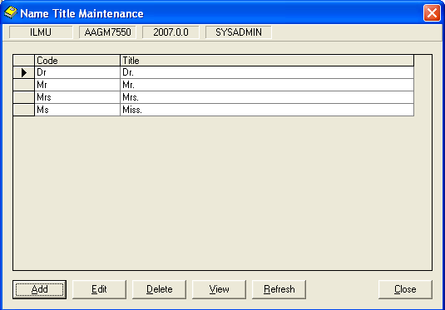

#### Add Name Title

**Steps**

1. From figure above, click on **Add** button. The following screen will be displayed.

Figure 8.187: Add Name Title dialog box

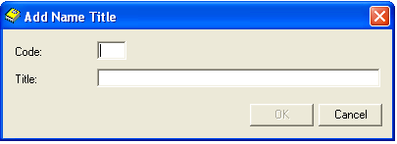

1. Fill the related details. You can see the **OK** button will be enabled after you have entered all the fields.
2. Click on the **OK** button.

#### View Name Title

**Steps**

1. Choose the **Name Title** that you want to view.
2. Click the **View** button. View Name Title dialog box will be displayed as below.

Figure 8.188: View Name Title dialog box

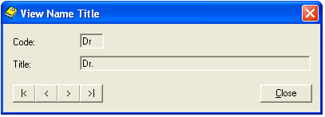

View the next or previous Bibliographic Source Code

1. Click the **Close** button, to close the View Name Title dialog box.

#### Edit Name Title

**Steps**

1. Choose the **Name Title** that you want to edit.
2. Click the **Edit** button. Edit Name Title dialog box will be displayed as below.

Figure 8.189: Edit Name Title dialog box

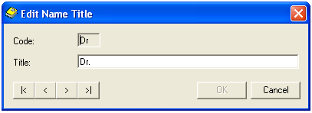

1. Make necessary amendments. **OK** button will be enabled. Click on **OK** button.

#### Delete Name Title

**Steps**

1. Choose the **Name Title** that you want to delete.
2. Click the **Delete** button. The message as below will be displayed.

Figure 8.190: Message prompt before deleting a record

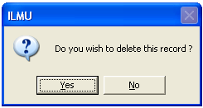

1. Click the **Yes** button. The highlighted record will be deleted.

Note **Note:**

Cannot delete the codes which used by other records.

Figure 8.191: Message prompt after deleting a record

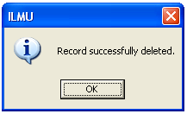

1. Click on **OK** button to close the dialog box.

#### Refresh Name Title

**Steps**

1. Click the **Refresh** button.
2. The **Name Title Maintenance**dialog box will be refreshed.
3. Click on **Close** button to close the dialog box.

### Module Access Level

The **Module Access Level** maintenance stores the module access level details.

**Steps**

1. Select **Foundation** module.
2. Click on **Maintenance** and then click the **Module Access Level** function.
3. The screen will be displayed as shown in figure below.

Figure 8.192: Module Access Level Maintenance dialog box

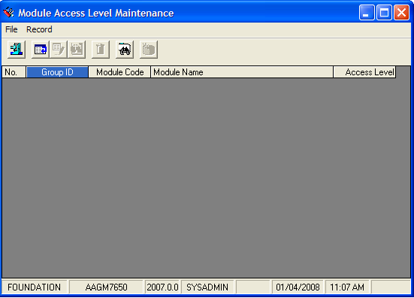

#### Add Module Access Level

**Steps**

1. From figure above, click on **Record** in tab menu*,* and choose **Add**, or
2. You can click on add icon,  to add the new Module Access Level.
3. The**Add Module Access Level**dialog box will be appeared as shown in figure below.

Figure 8.193: Add Module Access Level dialog box

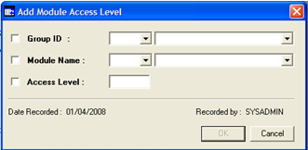

* + - 1. Fill in the related details.
      2. Click the **OK** button. The latest subject created will be displayed in **Module Access Level Maintenance** dialog box.
      3. Otherwise, you can click on **Cancel** button to cancel the process.

#### Find Existing Module Access Level

**Steps**

* + - 1. To find the existing Module Access record(s), click on **Record**tab and choose **Find** or
      2. Click on find icon,  in a screen to find the record(s)*.*  The **Search Criteria**dialog box will be appeared as shown in figure below.

Search term

Figure 8.194: Search criteria dialog box

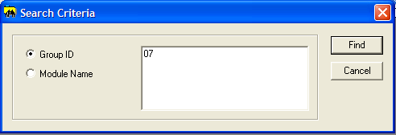

* + - 1. Choose search criteria by clicking a radio button. You can choose the criteria by:
* Group ID
* Module Name
  + - 1. Enter search term and click on **Find** button. The screen will display the related Module Access Level sets as shown in figure below.

Figure 8.195: Search Result

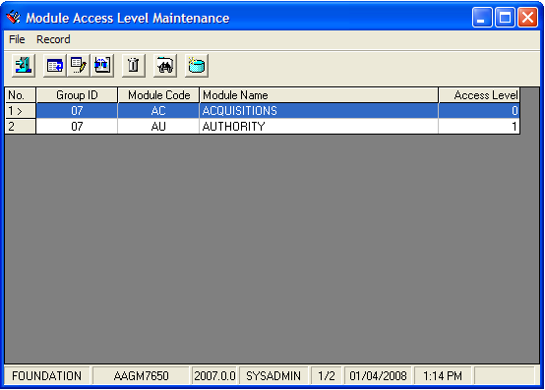

#### View Module Access Level

**Steps**

1. Click on **Record**tab and choose **View**, or
2. You can click the view icon*,*  to view the selected record. The **View Module Access Level** dialog box will be appeared as shown in figure below.

Figure 8.196: View Module Access Level dialog box

View the next or previous record(s).

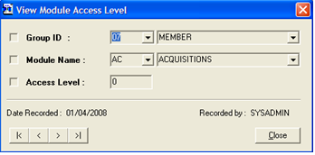

1. You can view the other record(s) by clicking on Next and Previous button as shown in figure above.
2. Then, click the **Close** button to close the View Module Access Level window.

#### Edit Module Access Level

**Steps**

1. The Module Access Level that has been created will be displayed in Module Access Level Maintenance dialog box. Highlight the row to edit its details.
2. Click on **Record**tab and choose **Edit**, or you can click the edit icon*,* .
3. The **Edit Module Access Level** dialog box will be appeared as shown in figure below.

Figure 8.197: Edit Module Access Level dialog box



1. Make necessary amendments.
2. Then, click the **OK** button. The record will be updated in **Module Access Maintenance** dialog box.

#### Delete Module Access Level

**Steps**

1. From Module Access Level Maintenance dialog box, highlight the row to delete Academic Subject details.
2. Click on **Record**tab and choose **Delete**, or you can click the delete icon*,* .
3. The screen will be displayed as shown in figure below.

Figure 8.198: Delete Module Access Level dialog box



1. Click on **Delete** button. A message box will be prompted as shown in figure below.

Figure 8.199: Prompt message



1. Click on **Yes** button. A successfully message will be appeared as shown in figure below. The record has been successfully deleted.

Figure 8.200: Successful message



1. Click the **OK** button to complete the process.

#### Refresh Module Access Level

**Steps**

1. Click on **Record**tab and choose **Refresh**, or you can click the refresh icon*,* *.*
2. The entire **Module Access Level Maintenance** dialog box will be refreshed.
3. Click on **Close** button to close the dialog box.

#### Closing Module Access Level

**Steps**

1. To close the Module Access Level Maintenance dialog box, click on **File** and choose **Close** or you can click the close icon .

### Religion Code

Religion Code Maintenance stored the religion code and description.

**Steps**

1. Select **Foundation** module.
2. Click on **Maintenance** and then **Religion Code.**
3. The screen will be displayed as shown in figure below.

#### Add Religion

**Steps**

1. In **Record** menu, choose **Add** or click on  icon.
2. **Add Tag Parameter** screen will appear as below.

Figure 8.201: Add Religion Code dialog box

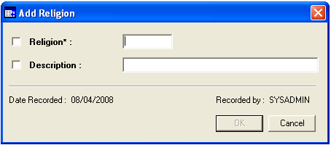

1. Fill in the related details. Notice the **OK** button is disabled.
2. Click on **OK** button to save the religion. If you wish to about this process, just click **Cancel** and the information will not be saved.

#### Find Religion

**Steps**

1. In **Record** menu, choose **Find** or click on  icon.
2. You will see **Search Criteria** screen will appear as below.

Figure 8.202: Search Criteria dialog box

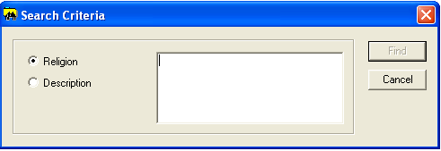

1. Choose a search criterion by clicking the selected radio button. Whether you want search using Religion or Description.
2. Enter the search criteria in the text area. Click on the **Find** button.
3. The search result will be displayed as below.

Figure 8.203: Search Result dialog box

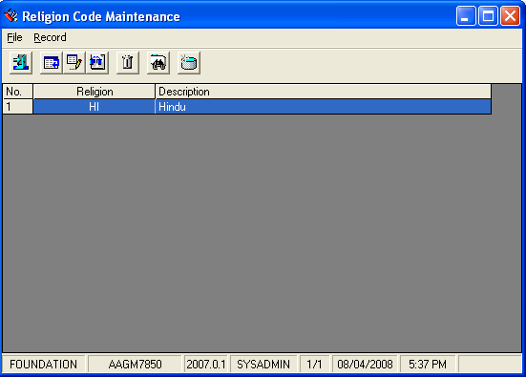

#### View Religion

**Steps**

1. Before viewing a particular tag parameter, first retrieve the record. Highlight a row to view its details.
2. After that in **Record** menu, choose **View** or click on  icon.
3. View Religion dialog box will be displayed.

Figure 8.204: View Religion dialog box

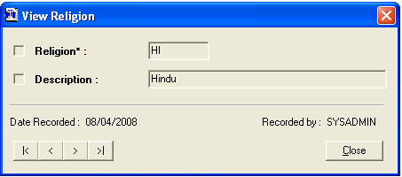

Browse Tag Parameter

1. Click the **Close** button to close the View Religiondialog box.

#### Edit Religion

**Steps**

1. Retrieve the tag parameter record before editing the particular record. Highlight a row to edit its details.
2. After that in **Record** menu, choose **Edit** or click on  icon.
3. Edit Patron Religion dialog box will be displayed.

Note **Note:**

Some of the records cannot be deleted because it’s have been using by other programs.

Figure 8.205: Edit Religion dialog box

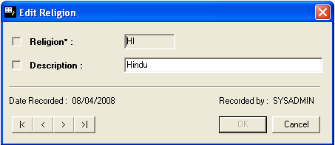

1. Make necessary amendments. Click **OK** button.

#### Delete Tag Religion

**Steps**

1. Retrieve patron religion that you want to delete. Highlight a row to delete its details.
2. After that in **Record** menu, choose **Delete** or click on  icon.
3. Delete Religion dialog box will be display as below.

Figure 8.206: Delete Religion dialog box



1. Click on **Delete** button.

Figure 8.207: Message prompt before deleting Religion

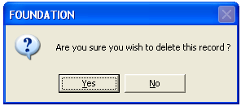

1. Click on **Yes** button to continue with deletion.
2. Click on **No** buttonto cancelthe deletion process.
3. If you successfully delete the religion a message prompts as below.

Figure 8.208: Message prompt after deleting Religion



#### Refresh Religion

**Steps**

1. In the **Record** menu, choose **Refresh** or click on icon.
2. The Religion Code Maintenance dialog box will be refreshed.

### Designation Code

Designation Code Maintenance stores the Designation details.

**Steps**

1. Select **Foundation** module.
2. Click on **Maintenance** and then click the **Designation Code** function.
3. The screen will be displayed as shown in figure below.

Figure 8.209: Designation Code Maintenance dialog box

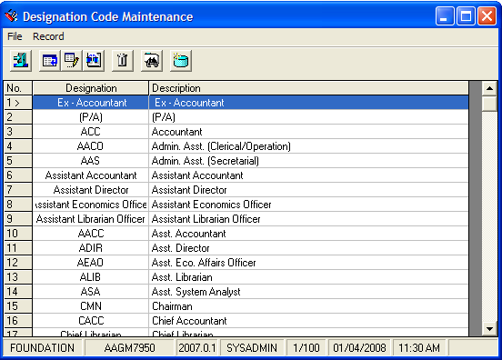

#### Add Designation Code

**Steps**

1. From figure above, click on **Record** in tab menu*,* and choose **Add**, or
2. You can click on add icon,  to add the new Designation Code.
3. The**Add Designation Code**dialog box will be appeared as shown in figure below.

Figure 8.210: Add Designation Code dialog box

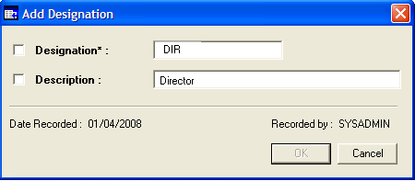

* + - 1. Fill in the related details.
      2. Click the **OK** button. The latest subject created will be displayed in **Module Access Level Maintenance** dialog box.
      3. Otherwise, you can click on **Cancel** button to cancel the process.

#### Find Existing Designation Code

**Steps**

* + - 1. To find the existing Designation Code record(s), click on **Record**tab and choose **Find** or
      2. Click on find icon,  in a screen to find the record(s)*.*  The **Search Criteria**dialog box will be appeared as shown in figure below.

Search term

Figure 8.211: Search criteria dialog box

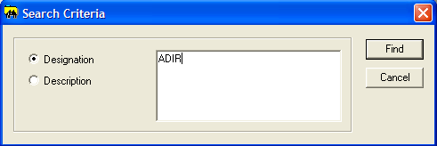

* + - 1. Choose search criteria by clicking a radio button. You can choose the criteria by:
* Designation
* Description
  + - 1. Enter search term and click on **Find** button. The screen will display the related Designation Code sets as shown in figure below.

Figure 8.212: Search Result

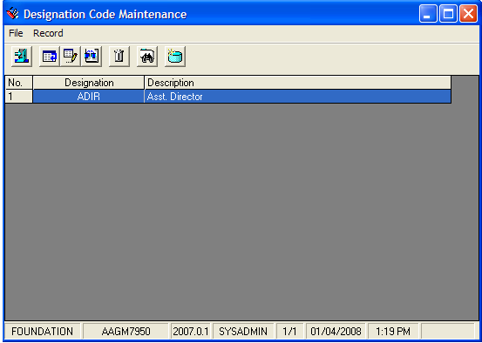

#### View Designation Code

**Steps**

1. Click on **Record**tab and choose **View**, or
2. You can click the view icon*,*  to view the selected record. The **View Designation Code** dialog box will be appeared as shown in figure below.

View the next or previous record(s).

Figure 8.213: View Designation Code dialog box

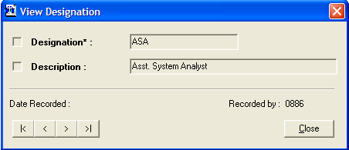

1. You can view the other record(s) by clicking on Next and Previous button as shown in figure above.
2. Then, click the **Close** button to close the View Designation Code window.

#### Edit Designation Code

**Steps**

1. The Designation Code that has been created will be displayed in Designation Code Maintenance. Highlight the row to edit its details.
2. Click on **Record**tab and choose **Edit**, or you can click the edit icon*,* .
3. The **Edit Designation Code** dialog box will be appeared as show in figure below.

Figure 8.214: Designation Code dialog box

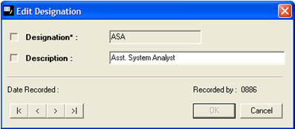

1. Make necessary amendments.
2. Then, click the **OK** button. The record will be updated in **Designation Code** dialog box.

#### Delete Designation Code

**Steps**

1. From Designation Code Maintenance dialog box, highlight the row to delete Academic Subject details.
2. Click on **Record**tab and choose **Delete**, or you can click the delete icon*,* .
3. The screen will be displayed as shown in figure below.

Figure 8.215: Delete Designation Code dialog box

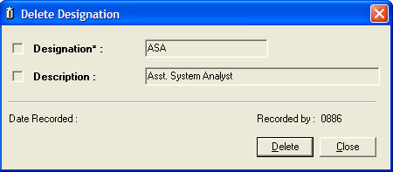

1. Click on **Delete** button. A message box will be prompted as shown in figure below.

Figure 8.216: Prompt message



1. Click on **Yes** button. A successfully message will be appeared as shown in figure below. The record has been successfully deleted.

Figure 8.217: Successful message



1. Click the **OK** button to complete the process.

#### Refresh Designation Code

**Steps**

1. Click on **Record**tab and choose **Refresh**, or you can click the refresh icon*,* *.*
2. The entire **Designation Code Maintenance** dialog box will be refreshed.
3. Click on **Close** button to close the dialog box.

#### Closing Designation Code

**Steps**

1. To close the Designation Code Maintenance dialog box, click on **File** and choose **Close** or you can click the close icon.

### Acquisitions Mode

Acquisitions Mode Maintenance stored Acquisitions mode details.

**Steps**

1. Select **Foundation** module.
2. Click on **Maintenance** and then **Acquisition Mode.**
3. The screen will be displayed as shown in figure below.

Figure 8.218: Acquisition Mode dialog box



#### Add Acquisition Mode

**Steps**

1. From figure above, click on **Add** button. The following screen will be displayed.

Figure 8.219: Add Acquisition Mode dialog box

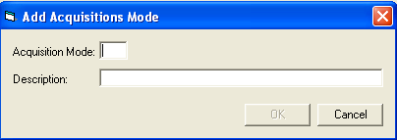

1. Enter values for **Acquisition Mode** and **Description**.
2. You can see the **OK** button will be enabled after you have entered the fields.
3. Click on the **OK** button.

#### View Acquisition Mode

**Steps**

1. Choose the **Acquisition Mode** that you want to view.
2. Click the **View** button. View Acquisition Mode dialog box will be displayed as below.

Figure 8.220: View Acquisition Mode dialog box

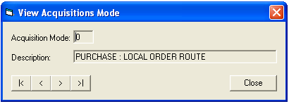

View the next or previous Acquisition Mode

1. Click the **Close** button, to close the View Acquisition Mode dialog box.

Note **Note:**

Cannot delete the codes which used by other records.

#### Edit Acquisition Mode

**Steps**

1. Choose the **Acquisition Mode** that you want to edit.
2. Click the **Edit** button. Edit Acquisition dialog box will be displayed. See below.

Figure 8.221: Edit Acquisition Mode dialog box

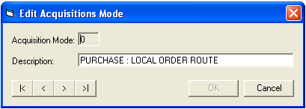

1. Make necessary amendments. **OK** button will be enabled. Click on **OK** button.

#### Delete Acquisition Mode

**Steps**

1. Choose the **Acquisition Mode** that you want to delete.
2. Click the **Delete** button. The message as below will be displayed.

Figure 8.222: Message prompt before deleting a record



1. Click the **Yes** button. The highlighted record will be deleted.

Figure 8.223: Message prompt after deleting a record

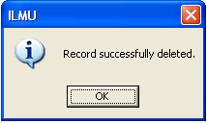

1. Click on **OK** button to close the dialog box.

#### Refresh Acquisition Mode

**Steps**

1. Click the **Refresh** button.
2. The **Acquisition Mode Maintenance**dialog box will be refreshed.
3. Click on **Close** button to close the dialog box.

### Acquisition Status

The **Acquisitions Status** maintenance stores the Acquisitions Status details.

**Steps**

1. Select **Foundation** module.
2. Click on **Maintenance** and then click the **Acquisitions Status** function.
3. The screen will be displayed as shown in figure below.

Figure 8.224: Acquisitions Status dialog box

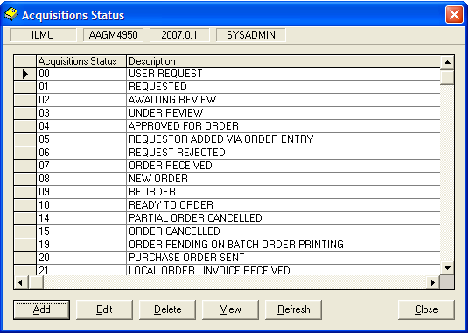

#### Add Acquisitions Status

**Steps**

1. From figure above, click on **Add** button. The following screen will be displayed.

Figure 8.225: Add Acquisitions Status dialog box

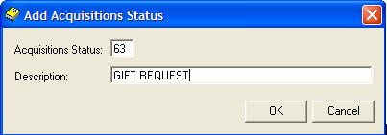

1. Enter the Acquisitions Status in text box and the description as shown in figure above.
2. Click on **OK** button. The latest Acquisitions Status created will be displayed in Acquisitions Status dialog box as shown in figure below.
3. Otherwise, you can click on **Cancel** button to cancel the process.

Figure 8.226: Display the created record(s)

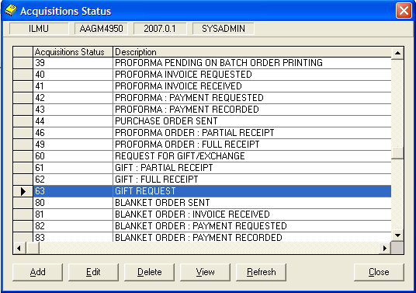

#### View Acquisitions Status

**Steps**

1. Acquisitions Status that has been created will be displayed in Acquisitions Status dialog box. Highlight the row to view its details.
2. Click the **View** button. **View Acquisitions Status** dialog box will be displayed as shown in figure below.

Figure 8.227: View Acquisitions Status dialog box

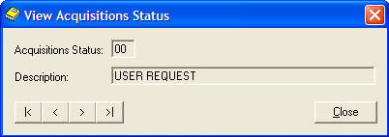

1. Click on **Close** button to close the dialog box

#### Edit Acquisitions Status

**Steps**

1. From figure above, highlight the row to edit Acquisitions Status details.
2. Click on **Edit** button. The **Edit Acquisitions Status** dialog box will be appeared as shown in figure below

Figure 8.228: Edit Acquisitions Status

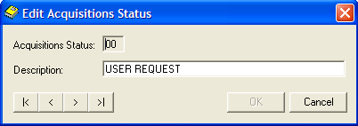

1. Make necessary amendments.
2. Then, click the **OK** button. The record will be updated in Acquisitions Status dialog box.
3. You can edit the other record(s) by clicking on Next and Previous button as shown in figure above.
4. Otherwise, you can click on **Cancel** button to cancel the process.

#### Delete Acquisitions Status

**Steps**

1. From Acquisitions Status dialog box, highlight the row to delete Acquisitions Status details.
2. Click on **Delete** button. The message dialog box will be appeared as shown in figure below.

Figure 8.229: Prompt Message dialog box



1. Click on **Yes** button. The highlighted record will be deleted. The successful message will be displayed as shown in figure below.
2. Otherwise, you can click on **No** button to cancel the process.

Figure 8.230: Successful message



1. Click on **OK** button to complete the process.

#### Refresh Acquisitions Status

**Steps**

1. Click the **Refresh** button.
2. The **Acquisitions Status** dialog box will be refreshed.
3. Click on **Close** button to close the dialog box.

### Acquisition Payment Mode

Acq Payment Mode Maintenance stored the different type of payment mode. For an example check payment, cash payment and etc.

**Steps**

1. Select **Foundation** module.
2. Click on **Maintenance** and then **Acq Payment Mode.**
3. The screen will be displayed as shown in figure below.

Figure 8.231: Acq Payment Mode dialog box

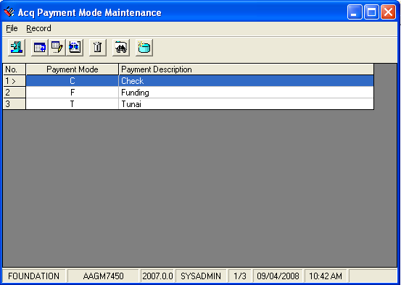

#### Add Acq Payment Mode

**Steps**

1. In **Record** menu, choose **Add** or click on  icon.
2. **Add Acq Payment Mode** screen will appear as below.

Figure 8.232: Add Acq Payment Mode dialog box

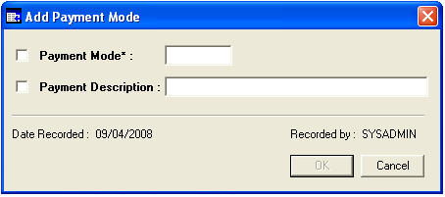

1. Fill in the related details. Notice the **OK** button is disabled.
2. Click on **OK** button to save the religion. If you wish to about this process, just click **Cancel** and the information will not be saved.

#### Find Acq Payment Mode

**Steps**

1. In **Record** menu, choose **Find** or click on  icon.
2. You will see **Search Criteria** screen will appear as below.

Figure 8.233: Search Criteria dialog box

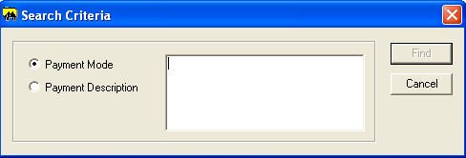

1. Choose a search criterion by clicking the selected radio button. Whether you want search using Payment Mode or Payment Description.
2. Enter the search criteria in the text area. Click on the **Find** button.
3. The search result will be displayed as below.

#### View Acq Payment Mode

**Steps**

1. Before viewing a particular Acq Payment Mode, first retrieve the record. Highlight a row to view its details.
2. After that in **Record** menu, choose **View** or click on  icon.
3. View Payment Mode box will be displayed.

Figure 8.234: View Payment Mode dialog box

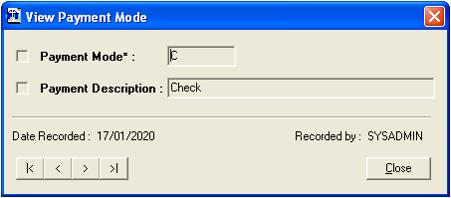

Browse Payment Mode

1. Click the **Close** button to close the View Payment Modedialog box.

#### Edit Acq Payment Mode

**Steps**

1. Retrieve the payment mode record before editing the particular record. Highlight a row to edit its details.
2. After that in **Record** menu, choose **Edit** or click on  icon.
3. Edit payment mode dialog box will be displayed.

Figure 8.235: Edit Payment Mode dialog box

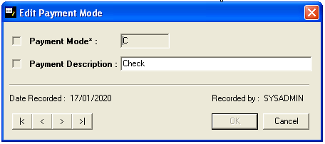

1. Make necessary amendments. Click **OK** button.

#### Delete Acq Payment Mode

**Steps**

1. Retrieve payment mode that you want to delete. Highlight a row to delete its details.
2. After that in **Record** menu, choose **Delete** or click on  icon.
3. Delete Payment Mode dialog box will be display as below.

Figure 8.236: Delete Payment Mode dialog box

Note **Note:**

Some of the records cannot be deleted because it’s have been using by other programs.

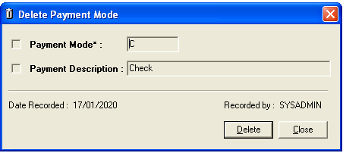

1. Click on **Delete** button.

Figure 8.237: Message prompt before deleting Payment Mode



1. Click on **Yes** button to continue with deletion.
2. Click on **No** buttonto cancelthe deletion process.
3. If you successfully delete the payment mode a message prompts as below.

Figure 8.238: Message prompt after deleting Payment Mode

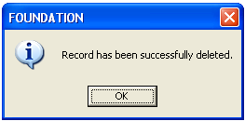

#### Refresh Acq Payment Mode

**Steps**

1. In the **Record** menu, choose **Refresh** or click on icon.
2. The Acq Payment Mode Maintenance dialog box will be refreshed.

### Flag

The **Flag** maintenance function stores the sets of parameters.

**Steps**

1. Select **Foundation** module.
2. Click on **Maintenance** and then click the **Flag** function.
3. The screen will be displayed as shown in figure below.

Figure 8.239: Flag Maintenance dialog box

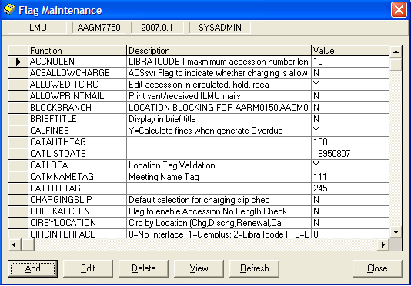

**Steps**

1. From figure above, click on **Add** button. The following screen will be displayed.

Figure 8.240: Add Flag Maintenance dialog box

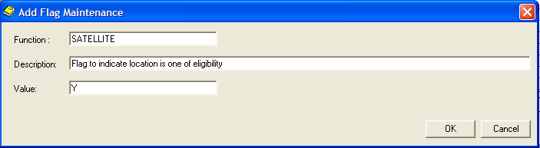

1. Enter the **Function**, **Description** and **Value** in a textbox fields as shown in figure above.
2. Click on **OK** button. The latest Flag created will be displayed in Flag Maintenance dialog box as shown in figure below.
3. Otherwise, you can click on **Cancel** button to cancel the process.

Figure 8.241: Display the created record(s)

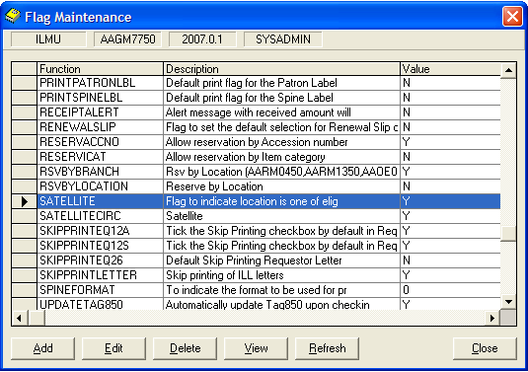

#### Add Flag

**Steps**

1. From figure above, click on **Add** button. The following screen will be displayed.

Figure 8.242: Add Flag dialog box

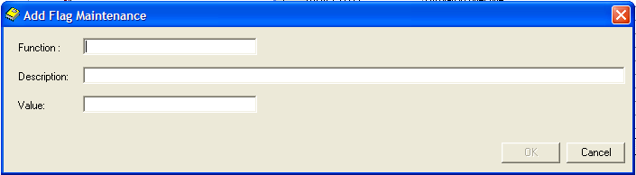

1. Enter the **Function** of the flag, **Description** and **Value** in a textbox fields as shown in figure above.
2. Click on **OK** button. The latest Flag created will be displayed in Flag Maintenance dialog box as shown in figure below.
3. Otherwise, you can click on **Cancel** button to cancel the process.

Figure 8.243: Display the created record(s)

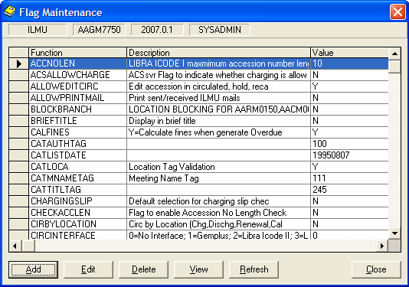

#### View Flag

**Steps**

1. Flag that has been created will be displayed in Flag Maintenance dialog box. Highlight the row to view its details.
2. Click the **View** button. **View Flag Maintenance** dialog box will be displayed as shown in figure below.

Figure 8.244: View Flag Maintenance dialog box

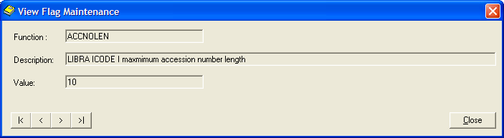

1. Click on **Close** button to close the dialog box

#### Edit Flag

**Steps**

1. From figure above, highlight the row to edit Flag details.
2. Click on **Edit** button. The **Edit Flag Maintenance** dialog box will be appeared as shown in figure below

Figure 8.245: Edit Flag Maintenance dialog box

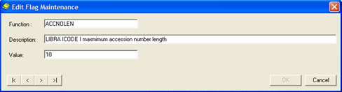

1. Make necessary amendments.
2. Then, click the **OK** button. The record will be updated in Flag Maintenance dialog box.
3. You can edit the other record(s) by clicking on Next and Previous button as shown in figure above.
4. Otherwise, you can click on **Cancel** button to cancel the process.

#### Delete Flag

**Steps**

1. From Flag Maintenance dialog box, highlight the row to delete Flag details.
2. Click on **Delete** button. The message dialog box will be appeared as shown in figure below.

Figure 8.246: Prompt Message dialog box



1. Click on **Yes** button. The highlighted record will be deleted. The successful message will be displayed as shown in figure below.
2. Otherwise, you can click on **No** button to cancel the process.

Figure 8.247: Successful message



1. Click on **OK** button to complete the process.

#### Refresh Flag

**Steps**

1. Click the **Refresh** button.
2. The **Flag Maintenance** dialog box will be refreshed.
3. Click on **Close** button to close the dialog box.

### Error In Supply Code

Error In Supply Code Maintenance stores the error in supply details.

**Steps**

1. Select **Foundation** module.
2. Click on **Maintenance** and then **Error In Supply Code.**
3. The screen will be displayed as shown in figure below.

Figure 8.248: Error In Supply Code dialog box

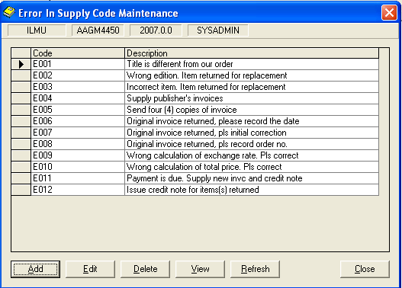

#### Add Error In Supply Code

**Steps**

1. From figure above, click on **Add** button. The following screen will be displayed.

Figure 8.249: Add Error In Supply Code dialog box

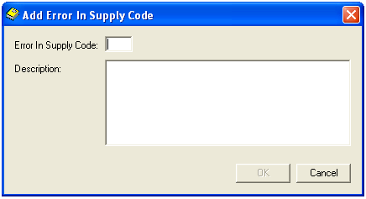

1. Fill in the related fields.
2. You can see the **OK** button will be enabled after you have entered the fields.
3. Click on the **OK** button.

#### View Error In Supply Code

**Steps**

1. Choose the **Error In Supply Code** that you want to view.
2. Click the **View** button. View Error In Supply Code dialog box will be displayed as below.

Figure 8.250: View Error In Supply Code dialog box

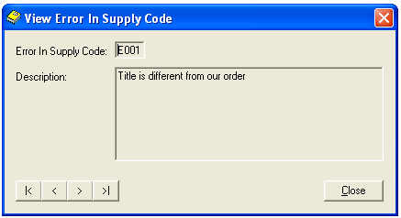

View the next or previous record

1. Click the **Close** button, to close the View Error In Supply Code dialog box.

#### Edit Error In Supply Code

**Steps**

1. Choose the **Error In Supply Code** that you want to edit.
2. Click the **Edit** button. Edit Error In Supply Code dialog box will be displayed as below.

Figure 8.251: Edit Error In Supply Code dialog box

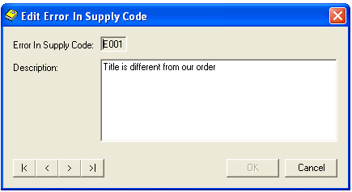

1. Make necessary amendments. **OK** button will be enabled. Click on **OK** button.

#### Delete Error In Supply Code

**Steps**

1. Choose the **Error In Supply Code that** you want to delete.
2. Click the **Delete** button. The message as below will be displayed.

Figure 8.252: Message prompt before deleting a record

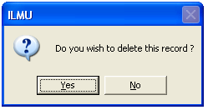

Note **Note:**

Cannot delete the codes which used by other records.

1. Click the **Yes** button. The highlighted record will be deleted.

Figure 8.253: Message prompt after deleting a record

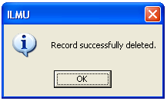

1. Click on **OK** button to close the dialog box.

#### Refresh Error In Supply Code

**Steps**

1. Click the **Refresh** button.
2. The **Error In Supply Code Maintenance**dialog box will be refreshed.
3. Click on **Close** button to close the dialog box.

### Vendor Feedback Code

Vendor Feedback Code stores the Vendor Feedback Code details.

**Steps**

1. Select **Foundation** module.
2. Click on **Maintenance** and then click the **Vendor Feedback Code** function.
3. The screen will be displayed as shown in figure below.

Figure 8.254: Vendor Feedback Code Maintenance dialog box

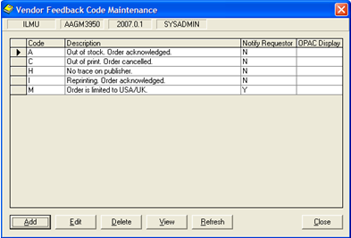

#### Add Vendor Feedback Code

**Steps**

1. From figure above, click on **Add** button. The following screen will be displayed.

Figure 8.255: Add Vendor Feedback Code dialog box

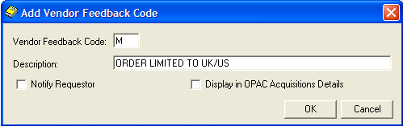

1. Enter the Vendor Feedback Code in text box and the description as shown in figure above.
2. Click on **OK** button. The latest Vendor Feedback Code created will be displayed in Vendor Feedback Code Maintenance dialog box as shown in figure below.
3. Otherwise, you can click on **Cancel** button to cancel the process.

Figure 8.256: Display the created record(s)

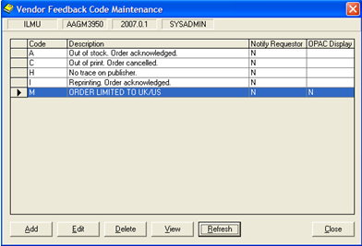

#### View Vendor Feedback Code

**Steps**

1. Vendor Feedback Code that has been created will be displayed in Vendor Feedback Code Maintenance dialog box. Highlight the row to view its details.
2. Click the **View** button. **View Vendor Feedback Code** dialog box will be displayed as shown in figure below.

Figure 8.257: View Vendor Feedback Code dialog box

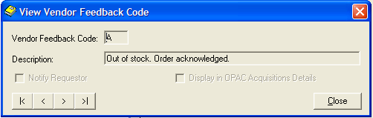

1. Click on **Close** button to close the dialog box

#### Edit Vendor Feedback Code

**Steps**

1. From figure above, highlight the row to edit Vendor Feedback Code details.
2. Click on **Edit** button. The **Edit Vendor Feedback Code** dialog box will be appeared as shown in figure below

Figure 8.258: Edit Vendor Feedback Code

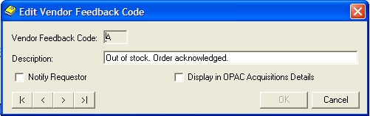

1. Make necessary amendments.
2. Then, click the **OK** button. The record will be updated in Vendor Feedback Code Maintenance dialog box.
3. You can edit the other record(s) by clicking on Next and Previous button as shown in figure above.
4. Otherwise, you can click on **Cancel** button to cancel the process.

#### Delete Vendor Feedback Code

**Steps**

1. From Vendor Feedback Code Maintenance dialog box, highlight the row to delete Vendor Feedback Code details.
2. Click on **Delete** button. The message dialog box will be appeared as shown in figure below.

Figure 8.259: Prompt Message dialog box



1. Click on **Yes** button. The highlighted record will be deleted. The successful message will be displayed as shown in figure below.
2. Otherwise, you can click on **No** button to cancel the process.

Figure 8.260: Successful message



1. Click on **OK** button to complete the process.

#### Refresh Vendor Feedback Code

**Steps**

1. Click the **Refresh** button.
2. The **Vendor Feedback Code Maintenance** dialog box will be refreshed.
3. Click on **Close** button to close the dialog box.

### Function Level Security

Function Level Security Maintenance allowed users to set the security level to add, delete and edit.

**Steps**

1. Select **Foundation** module.
2. Click on **Maintenance** and then **Function Level Security.**
3. The screen will be displayed as shown in figure below.

Figure 8.261: Function Level Security dialog box

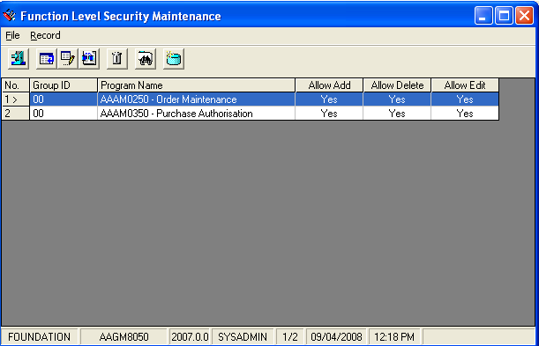

#### Add Function Level Security

**Steps**

1. In **Record** menu, choose **Add** or click on  icon.
2. **Add Function Level Security screen** will appear as below.

Figure 8.262: Add Function Level Security dialog box

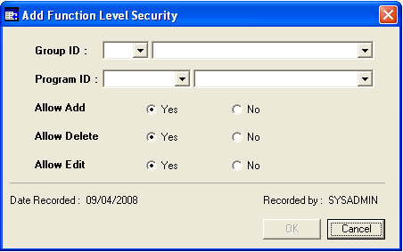

1. Fill in the related details by selecting values from the list boxes.
2. Click on the option button, either you allow users to add, delete or edit the Group ID or Program ID.
3. Notice the **OK** button is disabled.
4. Click on **OK** button to save the record. If you wish to about this process, just click **Cancel** and the information will not be saved.

#### Find Function Level Security

**Steps**

1. In **Record** menu, choose **Find** or click on  icon.
2. You will see **Search Criteria** screen will appear as below.

Figure 8.263: Search Criteria dialog box

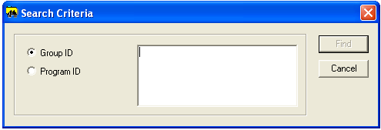

1. Choose a search criterion by clicking the selected radio button. Whether you want search using Group ID or Program ID.
2. Enter the search criteria in the text area. Click on the **Find** button.
3. The search result will be displayed as below.

#### View Function Level Security

**Steps**

1. Before viewing a particular Function Level Security, first retrieve the record. Highlight a row to view its details.
2. After that in **Record** menu, choose **View** or click on  icon.
3. View Function Level Security box will be displayed.

Figure 8.264: View Function Level Security dialog box

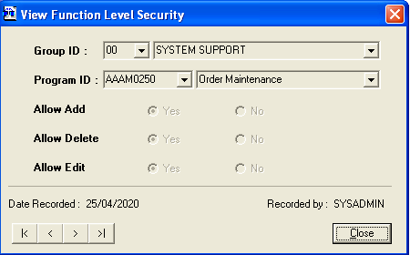

Browse Function Level Security

1. Click the **Close** button to close the View Function Level Securitydialog box.

#### Edit Function Level Security

**Steps**

1. Retrieve the record before editing the particular record. Highlight a row to edit its details.
2. After that in **Record** menu, choose **Edit** or click on  icon.
3. Edit Function Level Security dialog box will be displayed.

Figure 8.265: Edit Function Level Security dialog box

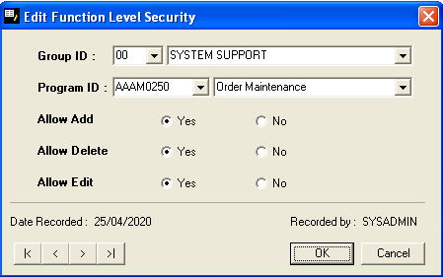

1. Make necessary amendments. Click **OK** button.

#### Delete Function Level Security

**Steps**

1. Retrieve the record that you want to delete. Highlight a row to delete its details.
2. After that in **Record** menu, choose **Delete** or click on  icon.
3. Delete Function Level Security dialog box will be display as below.

Figure 8.266: Delete Function Level Security dialog box

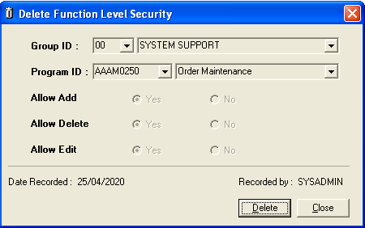

1. Click on **Delete** button.

Figure 8.267: Message prompt before deleting Function Level Security

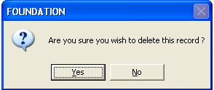

1. Click on **Yes** button to continue with deletion.
2. Click on **No** buttonto cancelthe deletion process.
3. If you successfully delete the payment mode a message prompts as below.

Figure 8.268: Message prompt after deleting Function Level Security

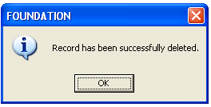

#### Refresh Function Level Security

**Steps**

1. In the **Record** menu, choose **Refresh** or click on icon.
2. The Function Level Security Maintenance dialog box will be refreshed.

### Stop Word

Stop Word stores the words which include as part of the searching process.

**Steps**

1. Select **Foundation** module.
2. Click on **Maintenance** and then click the **Stop Word** function.
3. The screen will be displayed as shown in figure below.

Figure 8.269: Stop Word dialog box

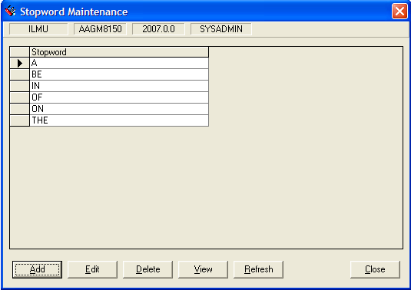

#### Add Stop Word

**Steps**

1. From figure above, click on **Add** button. The following screen will be displayed.

Figure 8.270: Add Stopword dialog box

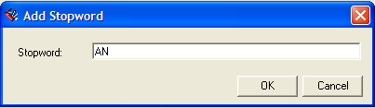

1. Enter the Stop Word in text box and the description as shown in figure above.
2. Click on **OK** button. The latest Stop Word created will be displayed in Stopword Maintenance dialog box as shown in figure below.
3. Otherwise, you can click on **Cancel** button to cancel the process.

Figure 8.271: Display the created record(s)

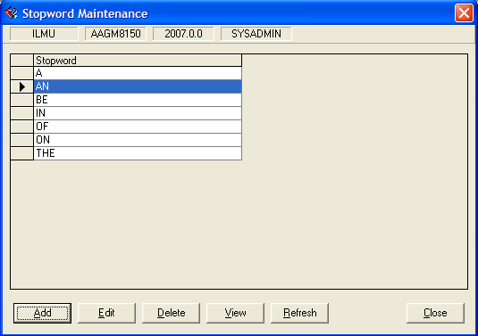

#### View Stop Word

**Steps**

1. Stop Word that has been created will be displayed in Stopword Maintenance dialog box. Highlight the row to view its details.
2. Click the **View** button. **View Stopword** dialog box will be displayed as shown in figure below.

Figure 8.272: View Stopword dialog box

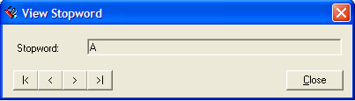

1. Click on **Close** button to close the dialog box

#### Edit Stop Word

**Steps**

1. From figure above, highlight the row to edit Stopword details.
2. Click on **Edit** button. The **Edit Stopword** dialog box will be appeared as shown in figure below

Figure 8.273: Edit Stopword dialog box

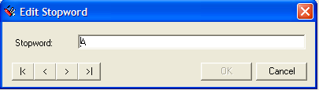

1. Make necessary amendments.
2. Then, click the **OK** button. The record will be updated in Stopword Maintenance dialog box.
3. You can edit the other record(s) by clicking on Next and Previous button as shown in figure above.
4. Otherwise, you can click on **Cancel** button to cancel the process.

#### Delete Stop Word

**Steps**

1. From Stopword Maintenance dialog box, highlight the row to delete Stopword details.
2. Click on **Delete** button. The message dialog box will be appeared as shown in figure below.

Figure 8.274: Prompt Message dialog box



1. Click on **Yes** button. The highlighted record will be deleted. The successful message will be displayed as shown in figure below.
2. Otherwise, you can click on **No** button to cancel the process.

Figure 8.275: Successful message



1. Click on **OK** button to complete the process.

#### Refresh Stop Word

**Steps**

1. Click the **Refresh** button.
2. The **Stopword Maintenance** dialog box will be refreshed.
3. Click on **Close** button to close the dialog box.

### Letter Format Editor

Letter Format Editor used to format the letters.

**Steps**

1. Select **Foundation** module.
2. Click on **Maintenance** and then **Letter Format Editor.**
3. The screen will be displayed as shown in figure below.

Figure 8.276: Letter Editor dialog box

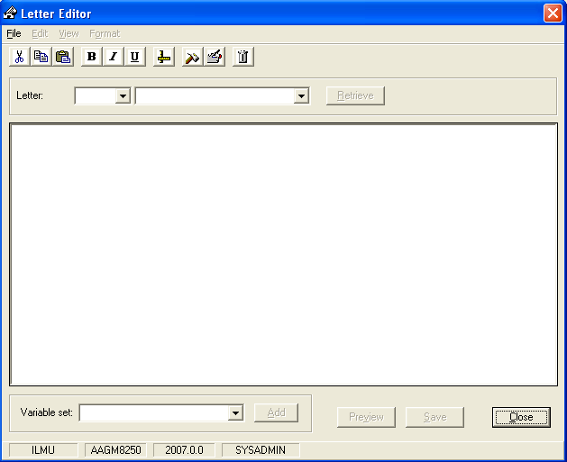

1. Choose one of the letter’s from the list box. After that click on the **Retrieve** button.
2. You can see the letter displayed as below.

Figure 8.277: An example Letter

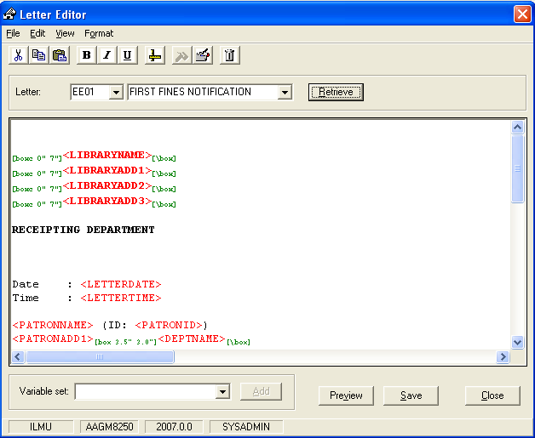

#### Set Variable

**Steps**

1. From figure above, click on **Add** button. The following screen will be displayed.
2. Choose the variable from **Variable set box.** Add the variable in the letter above. Example will be shown as below.

Figure 8.278: After added a variable in the letter

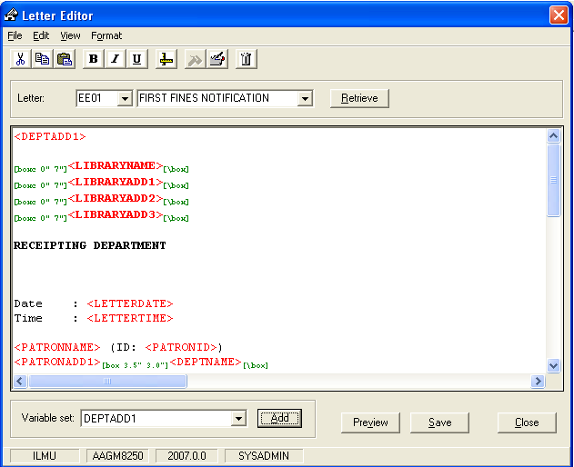

1. Click on the **Save** button after added the variable.

#### Set Column

**Steps**

1. Highlight the variable that you have added.
2. Then click **Set Column** from Format menu or click on  icon. **Column Properties** dialog box display as below.

Figure 8.279: Column Properties dialog box

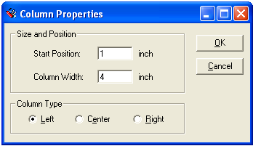

1. Then click **Set Column** from Format menu or click on  icon. **Column Properties** dialog box display as below.
2. Set **Size and Position**, **Column Type.** After set the values, click on **OK** button. You will see the difference. See the figure below.

Figure 8.280: After set the column for variable

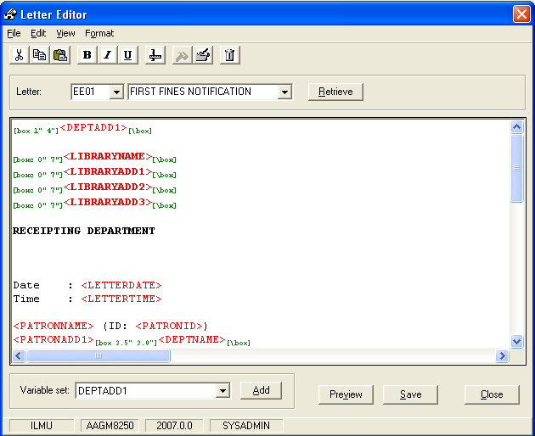

#### Delete Variable

**Steps**

1. Highlight the variable that you want to delete.
2. Then click **Delete Variable** from Edit menu or click on  icon. The selected variable will be deleted.

#### Set Column

**Steps**

1. Highlight the variable that you have added.
2. Then click **Set Column** from Format menu or click on  icon.

#### Page Setup

**Steps**

1. Choose **Page Setup** from **File** menu. The below screen will be displayed.

Figure 8.281: Page Setup screen

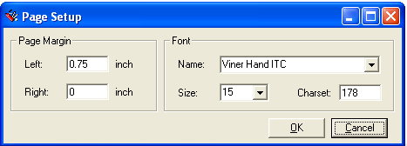

1. Do the changes that you need.
2. Then click on **OK** button.

#### Print Preview Letter

**Steps**

1. Click on **Preview** button in Letter Edit figure.
2. The page below will be displayed.

Figure 8.282: Print Preview the letter

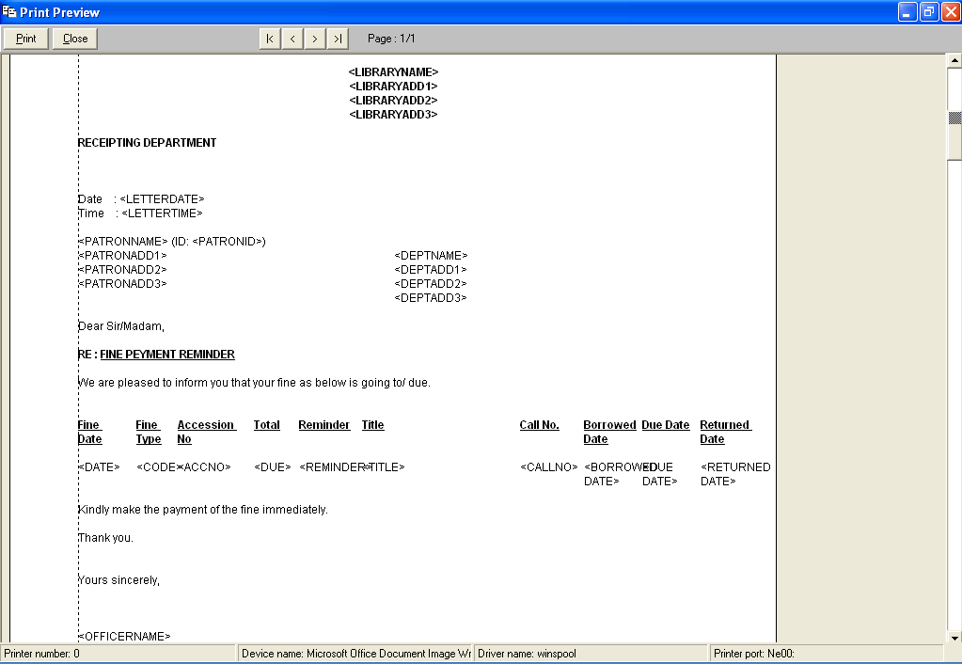

1. Click on **Print** button to print the letter.
2. Otherwise click on **Close** button to close the print preview page.

### Non-Filling Characters

Non-Filling Characters stores a character which to be ignored by system when it appear at the beginning of cataloging data in access fields.

**Steps**

1. Select **Foundation** module.
2. Click on **Maintenance** and then click the **Non-Filling Characters** function.
3. The screen will be displayed as shown in figure below.

Figure 8.283: Non-Filling Characters Maintenance dialog box

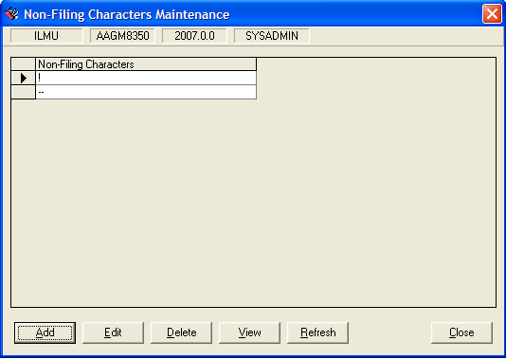

#### Add Non-Filling Characters

**Steps**

1. From figure above, click on **Add** button. The following screen will be displayed.

Figure 8.284: Add Non-Filling Characters dialog box

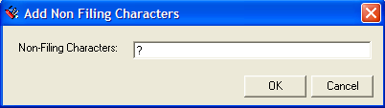

1. Enter the Non-Filling Characters and the description in text box fields as shown in figure above.
2. Click on **OK** button. The latest Non-Filling Characters created will be displayed in Non-Filling Characters Maintenance dialog box as shown in figure below.
3. Otherwise, you can click on **Cancel** button to cancel the process.

Figure 8.285: Display the created record(s)

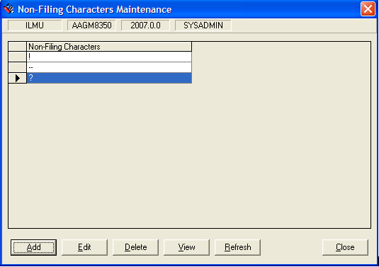

#### View Non-Filling Characters

**Steps**

1. Non-Filling Characters that has been created will be displayed in Non-Filling Characters Maintenance dialog box. Highlight the row to view its details.
2. Click the **View** button. **View Non-Filling Characters** dialog box will be displayed as shown in figure below.

Figure 8.286: View Non-Filling Characters dialog box

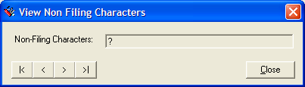

1. Click on **Close** button to close the dialog box

#### Edit Non-Filling Characters

**Steps**

1. From figure above, highlight the row to edit Vendor Feedback Code details.
2. Click on **Edit** button. The **Edit Non-Filling Characters** dialog box will be appeared as shown in figure below

Figure 8.287: Edit Non-Filling Characters dialog box

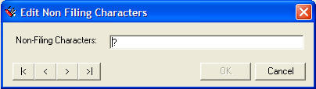

1. Make necessary amendments.
2. Then, click the **OK** button. The record will be updated in Non-Filling Characters Maintenance dialog box.
3. You can edit the other record(s) by clicking on Next and Previous button as shown in figure above.
4. Otherwise, you can click on **Cancel** button to cancel the process.

#### Delete Non-Filling Characters

**Steps**

1. From Non-Filling Characters Maintenance dialog box, highlight the row to delete Non-Filling Characters details.
2. Click on **Delete** button. The message dialog box will be appeared as shown in figure below.

Figure 8.288: Prompt Message dialog box



1. Click on **Yes** button. The highlighted record will be deleted. The successful message will be displayed as shown in figure below.
2. Otherwise, you can click on **No** button to cancel the process.

Figure 8.289: Successful message



1. Click on **OK** button to complete the process.

#### Refresh Non-Filling Characters

**Steps**

1. Click the **Refresh** button.
2. The **Non-Filling Characters** dialog box will be refreshed.
3. Click on **Close** button to close the dialog box.

### Serial Frequency

Serials Frequency Maintenance stores the serials frequencies details.

**Steps**

1. Select **Foundation** module.
2. Click on **Maintenance** and then **Serial Frequency.**
3. The screen will be displayed as shown in figure below.

Figure 8.290: Serial Frequency Maintenance dialog box

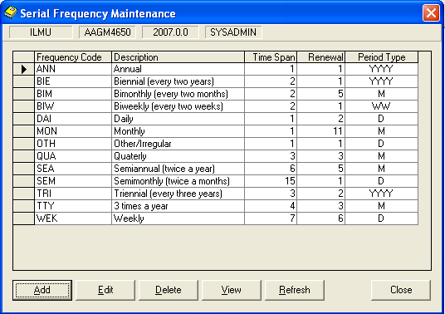

#### Add Frequency Code

**Steps**

1. From figure above, click on **Add** button. The following screen will be displayed.

Figure 8.291: Add Frequency Code dialog box

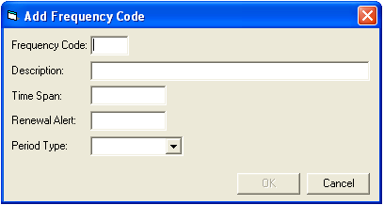

1. Fill in the related fields.
2. You can see the **OK** button will be enabled after you have entered the fields.
3. Click on the **OK** button.

#### View Frequency Code

**Steps**

1. Choose the **Frequency Code** that you want to view.
2. Click the **View** button. View Frequency Code dialog box will be displayed as below.

Figure 8.292: View Frequency Code dialog box

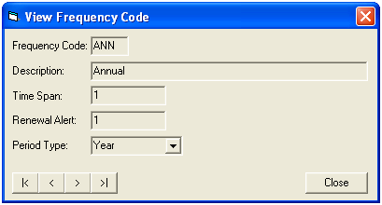

View the next or previous Frequency Record

1. Click the **Close** button, to close the View Frequency Code dialog box.

#### Edit Frequency Code

**Steps**

1. Choose the **Frequency Code** that you want to edit.
2. Click the **Edit** button. Edit Frequency Code dialog box will be displayed as below.

Figure 8.293: Edit Frequency Code dialog box

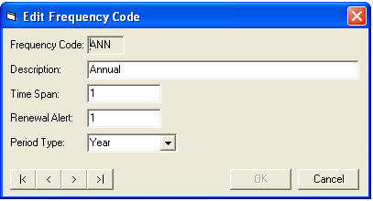

1. Make necessary amendments. **OK** button will be enabled. Click on **OK** button.

Note **Note:**

Cannot delete the codes which used by other programs

#### Delete Frequency Code

**Steps**

1. Choose the **Frequency Code** that you want to delete.
2. Click the **Delete** button. The message as below will be displayed.

Figure 8.294: Message prompt before deleting a record



1. Click the **Yes** button. The highlighted record will be deleted.

Figure 8.295: Message prompt after deleting a record



1. Click on **OK** button to close the dialog box.

#### Refresh Serial Frequency Maintenance

**Steps**

1. Click the **Refresh** button.
2. The **Serial Frequency Maintenance**dialog box will be refreshed.
3. Click on **Close** button to close the dialog box.

### Mail Type

Mail Type stores the various Mail Type details.

**Steps**

1. Select **Foundation** module.
2. Click on **Maintenance** and then click the **Mail Type** function.
3. The screen will be displayed as shown in figure below.

Figure 8.296: Mail Type Maintenance

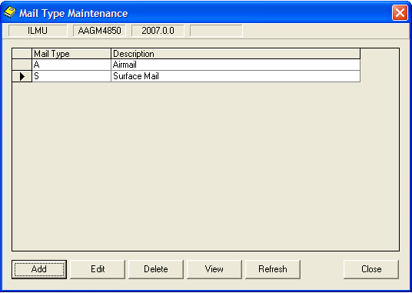

#### Add Mail Type

**Steps**

1. From figure above, click on **Add** button. The following screen will be displayed.

Figure 8.297: Add Mail Type Maintenance dialog box

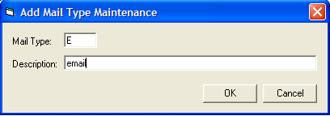

1. Enter the Mail Type and the description in a textbox fields as shown in figure above.
2. Click on **OK** button. The latest Mail Type created will be displayed in Mail Tpye Maintenance dialog box as shown in figure below.
3. Otherwise, you can click on **Cancel** button to cancel the process.

Figure 8.298: Display the created record(s)

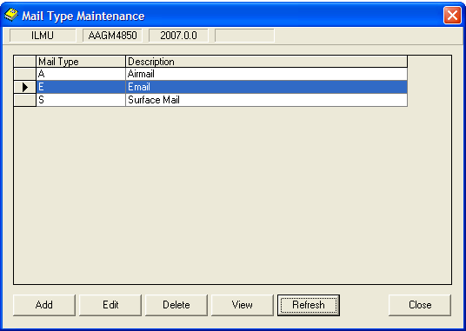

#### View Mail Type

**Steps**

1. Mail Type that has been created will be displayed in Mail Type Maintenance dialog box. Highlight the row to view its details.
2. Click the **View** button. **View Mail Type Maintenance** dialog box will be displayed as shown in figure below.

Figure 8.299: View Mail Type Maintenance dialog box

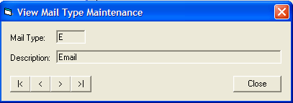

1. Click on **Close** button to close the dialog box

#### Edit Mail Type

**Steps**

1. From figure above, highlight the row to edit Mail Type details.
2. Click on **Edit** button. The **Edit Mail Type Maintenance** dialog box will be appeared as shown in figure below

Figure 8.300: Edit Mail Type Maintenance dialog box

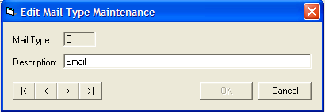

1. Make necessary amendments.
2. Then, click the **OK** button. The record will be updated in Mail Type Maintenance dialog box.
3. You can also edit the other record(s) by clicking on Next and Previous button as shown in figure above.
4. Otherwise, you can click on **Cancel** button to cancel the process.

#### Delete Mail Type

**Steps**

1. From Mail Type Maintenance dialog box, highlight the row to delete Mail Type details.
2. Click on **Delete** button. The message dialog box will be appeared as shown in figure below.

Figure 8.301: Prompt Message dialog box



1. Click on **Yes** button. The highlighted record will be deleted. The successful message will be displayed as shown in figure below.
2. Otherwise, you can click on **No** button to cancel the process.

Figure 8.302: Successful message



1. Click on **OK** button to complete the process.

#### Refresh Mail Type

**Steps**

1. Click the **Refresh** button.
2. The **Mail Type** dialog box will be refreshed.
3. Click on **Close** button to close the dialog box.

### Patron Miscellaneous Attributes

Patron Miscellaneous Attribute maintenance used to store all the miscellaneous for patron.

**Steps**

1. Select **Foundation** module.
2. Click on **Maintenance** and then **Patron Miscellaneous Attributes.**
3. The screen will be displayed as shown in figure below.

Figure 8.303: Patron Miscellaneous Attribute Maintenance dialog box

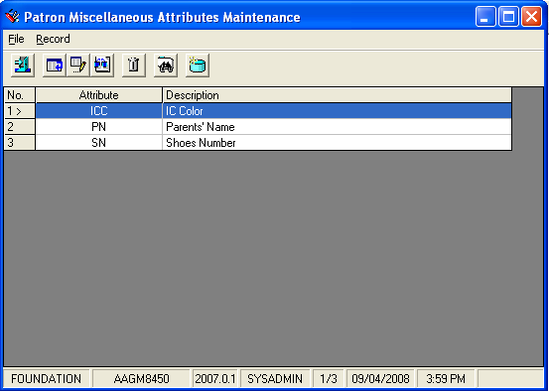

#### Add Patron Miscellaneous Attributes

**Steps**

1. In **Record** menu, choose **Add** or click on  icon.
2. **Add Attribute screen** will appear as below.

Figure 8.304: Add Attribute dialog box

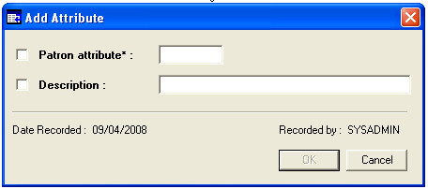

1. Fill the values for the related fields.
2. Notice the **OK** button is enabled.

#### Find Patron Miscellaneous Attributes

**Steps**

1. In **Record** menu, choose **Find** or click on  icon.
2. You will see **Search Criteria** screen will appear as below.

Figure 8.305: Search Criteria dialog box

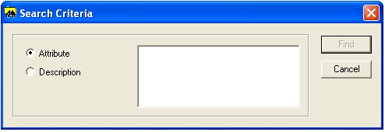

1. Choose a search criterion by clicking the selected radio button. Whether you want search using Attribute or Description.
2. Enter the search criteria in the text area. Click on the **Find** button.

#### View Patron Miscellaneous Attributes

**Steps**

1. Before viewing a patron miscellaneous attribute, first retrieve the record. Highlight a row to view its details.
2. After that in **Record** menu, choose **View** or click on  icon.
3. View Attribute dialog box will be displayed.

Figure 8.306: View Attribute dialog box

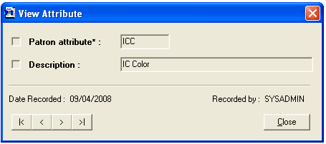

Browse Attributes

1. Click the **Close** button to close the View Attributedialog box.

#### Edit Patron Miscellaneous Attributes

**Steps**

1. Retrieve the record before editing the particular item. Highlight a row to edit its details.
2. After that in **Record** menu, choose **Edit** or click on  icon.
3. Edit Attribute dialog box will be displayed.

Figure 8.307: Edit Attribute dialog box

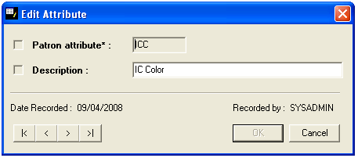

1. Make necessary amendments. Click **OK** button.

#### Delete Patron Miscellaneous Attributes

**Steps**

1. Retrieve the record that you want to delete. Highlight a row to delete its details.
2. After that in **Record** menu, choose **Delete** or click on  icon.
3. Delete Attribute dialog box will be display as below.

Figure 8.308: Delete Attribute dialog box

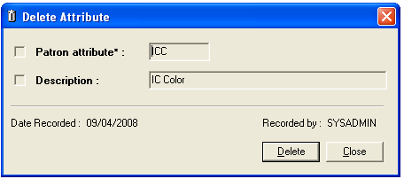

1. Click on **Delete** button.

Figure 8.309: Message prompt before deleting miscellaneous Attribute

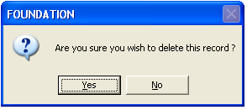

1. Click on **Yes** button to continue with deletion.
2. Click on **No** buttonto cancelthe deletion process.
3. If you successfully delete the payment mode a message prompts as below.

Figure 8.310: Message prompt after deleting miscellaneous Attribute



#### Refresh Patron Miscellaneous Attributes

**Steps**

1. In the **Record** menu, choose **Refresh** or click on icon.
2. The Patron Miscellaneous Attribute Maintenance dialog box will be refreshed.

### Language Code

Language Code Maintenance stores the Language Code details.

**Steps**

1. Select **Foundation** module.
2. Click on **Maintenance** and then **Language Code** function.
3. The screen will be displayed as shown in figure below.

Figure 8.311: Foundation dialog box

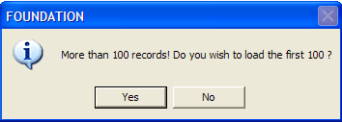

1. Click on **Yes** button to view all the record(s). The following screen will be displayed, please refer on Figure 8.171 below.
2. Otherwise, you can click on **No** button and refer to Figure 8.172 below.

Figure 8.312: Language Code Maintenance dialog box

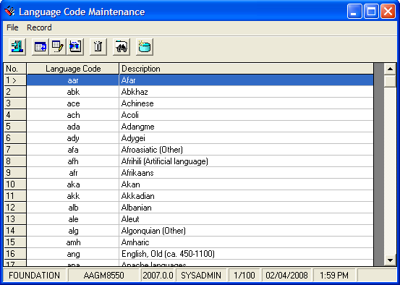

Figure 8.313: Language Code Maintenance

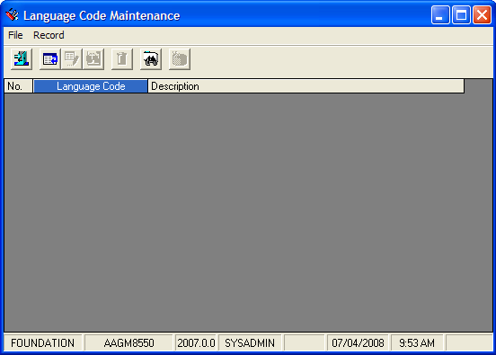

#### Add Language Code

**Steps**

1. From figure above, click on **Record** in tab menu*,* and choose **Add**, or
2. You can click on add icon,  to add the new Language Code.
3. The**Language** dialog box will be appeared as shown in figure below.

Figure 8.314: Add Language dialog box

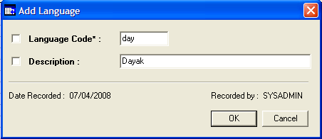

* + - 1. Fill in the related details.
      2. Click the **OK** button. The latest subject created will be displayed in **Language Code Maintenance** dialog box.
      3. Otherwise, you can click on **Cancel** button to cancel the process.

#### Find Existing Language Code

**Steps**

To find the existing Language Code record(s), click on **Record**tab and choose **Find** or

* + - 1. Click on find icon,  in a screen to find the record(s)*.*  The **Search Criteria**dialog box will be appeared as shown in figure below.

Search term

Figure 8.315: Search criteria dialog box

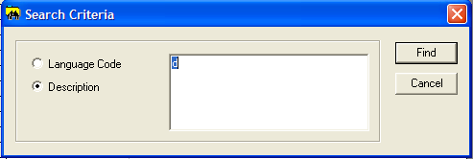

* + - 1. Choose search criteria by clicking a radio button. You can choose the criteria by:
* Language Code
* Description
  + - 1. Enter search term and click on **Find** button. The screen will display the related Language Code sets as shown in figure below.

Figure 8.316: Search Result

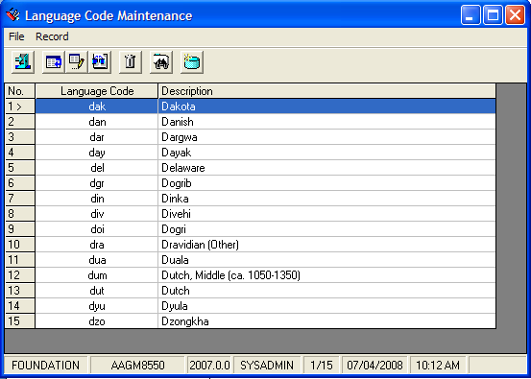

#### View Language Code

**Steps**

1. Click on **Record**tab and choose **View**, or
2. You can click the view icon*,*  to view the selected record. The **View Language** dialog box will be appeared as shown in figure below.

Figure 8.317: View Language dialog box

View the next or previous record(s).

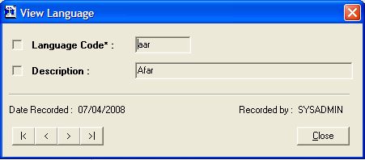

1. You can view the other record(s) by clicking on Next and Previous button as shown in figure above.
2. Then, click the **Close** button to close the View Language window.

#### Edit Language Code

**Steps**

1. The Language Code that has been created will be displayed in Language Code Maintenance dialog box. Highlight the row to edit its details.
2. Click on **Record**tab and choose **Edit**, or you can click the edit icon*,* .
3. The **Edit Language** dialog box will be appeared as shown in figure below.

Figure 8.318: Edit Language dialog box

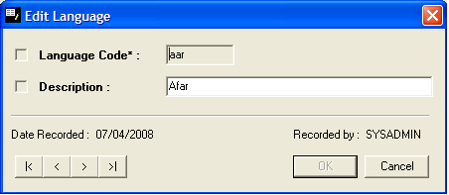

1. Make necessary amendments.
2. Then, click the **OK** button. The record will be updated in **Language Code Maintenance** dialog box.

#### Delete Language Code

**Steps**

1. From Language Code Maintenance dialog box, highlight the row to delete Language Code details.
2. Click on **Record**tab and choose **Delete**, or you can click the delete icon*,* .
3. The screen will be displayed as shown in figure below.

Figure 8.319: Delete Language dialog box

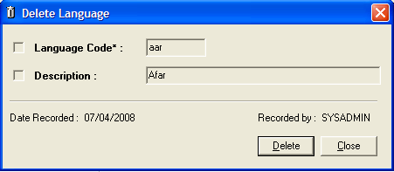

1. Click on **Delete** button. A message box will be prompted as shown in figure below.

Figure 8.320: Prompt message



1. Click on **Yes** button. A successfully message will be appeared as shown in figure below. The record has been successfully deleted.

Figure 8.321: Successful message



1. Click the **OK** button to complete the process.

#### Refresh Language Code

**Steps**

1. Click on **Record**tab and choose **Refresh**, or you can click the refresh icon*,* *.*
2. The entire **Language Maintenance** dialog box will be refreshed.
3. Click on **Close** button to close the dialog box.

#### Closing Language Code

**Steps**

1. To close the Language Code Maintenance dialog box, click on **File** and choose **Close** or you can click the close icon .

### Branch Code

Branch Code Maintenance stores the branch code details and description.

**Steps**

1. Select **Foundation** module.
2. Click on **Maintenance** and then **Branch Code.**
3. The screen will be displayed as shown in figure below.

Figure 8.322: Branch Code Maintenance dialog box

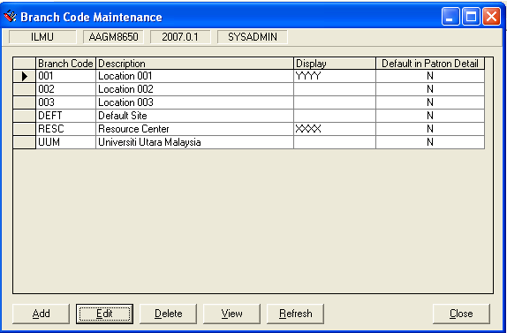

#### Add Branch Code

**Steps**

1. From figure above, click on **Add** button. The following screen will be displayed.

Figure 8.323: Add Branch Code dialog box

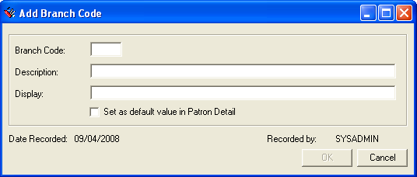

1. Fill in the related fields.
2. You can see the **OK** button will be enabled after you have entered the fields.
3. Click on the check box to set the value as default in Patron Detail.
4. Click on the **OK** button.

#### View Branch Code

**Steps**

1. Choose the **Branch Code** that you want to view.
2. Click the **View** button. View Branch Code dialog box will be displayed as below.

Figure 8.324: View Branch Code dialog box

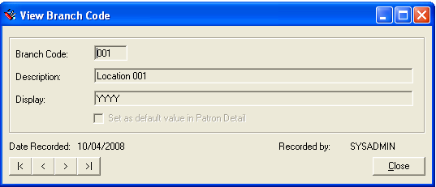

View the next or previous Branch Code

1. Click the **Close** button, to close the View Branch Code dialog box.

#### Edit Branch Code

**Steps**

1. Choose the **Branch Code** that you want to edit.
2. Click the **Edit** button. Edit Branch Code dialog box will be displayed as below.

Figure 8.325: Edit Branch Code dialog box

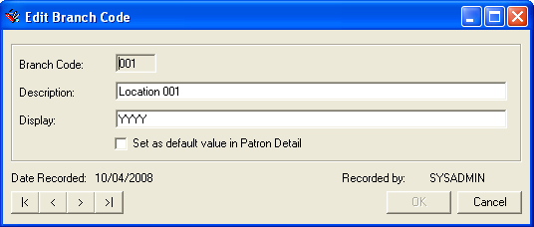

1. Make necessary changes.
2. Click on the check box, if you want to set the branch code as default in Patron Detail.
3. **OK** button will be enabled. Click on **OK** button.

Note **Note:**

Cannot delete the Branch codes which used by other programs

#### Delete Branch Code

**Steps**

1. Choose the **Branch Code** that you want to delete.
2. Click the **Delete** button. The message as below will be displayed.

Figure 8.326: Message prompt before deleting a record



1. Click the **Yes** button. The highlighted record will be deleted.

Figure 8.327: Message prompt after deleting a record

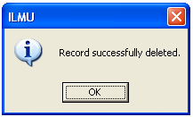

1. Click on **OK** button to close the dialog box.

#### Refresh Branch Code Maintenance

**Steps**

1. Click the **Refresh** button.
2. The **Branch Code Maintenance**dialog box will be refreshed.
3. Click on **Close** button to close the dialog box.